Summer Dance 8 July 2025 Allana Creighton

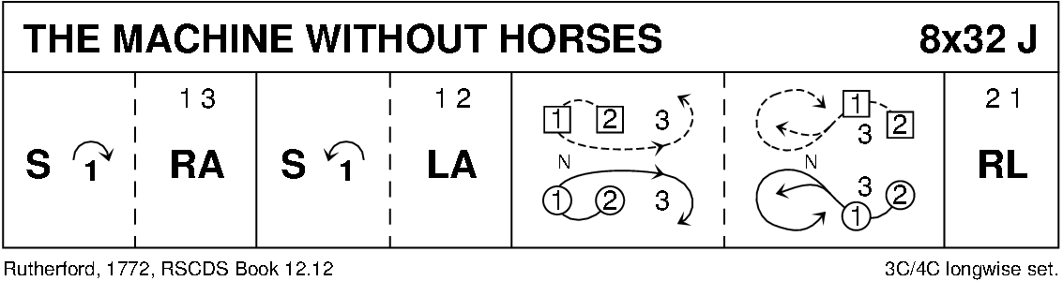

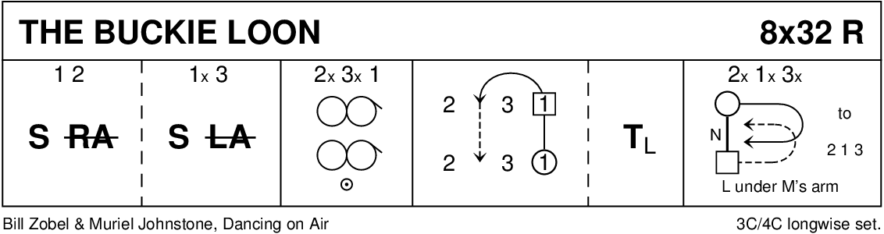

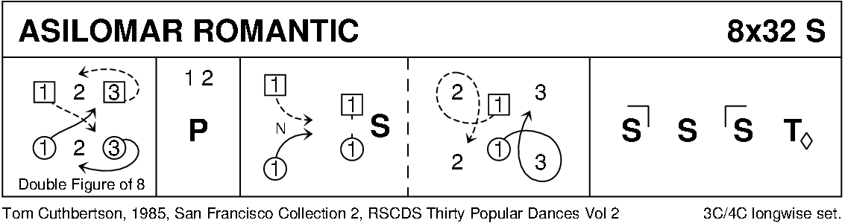

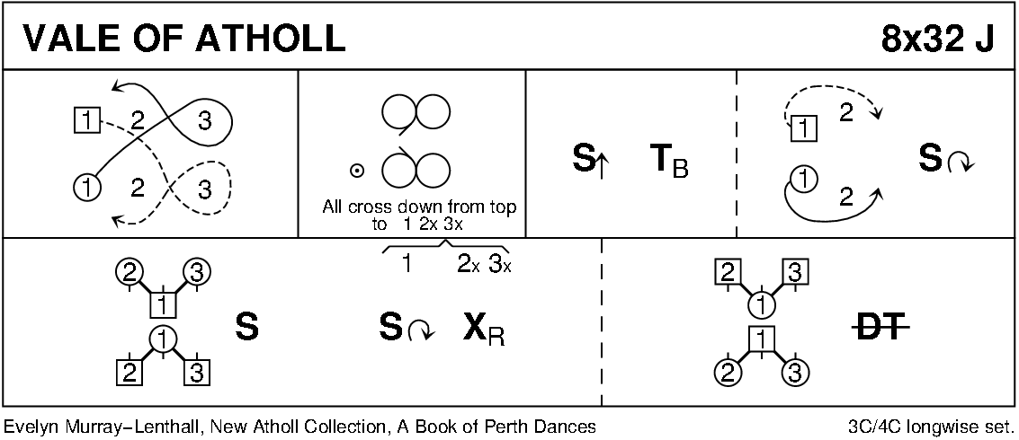

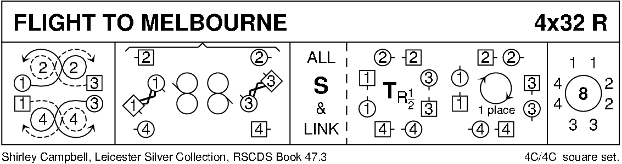

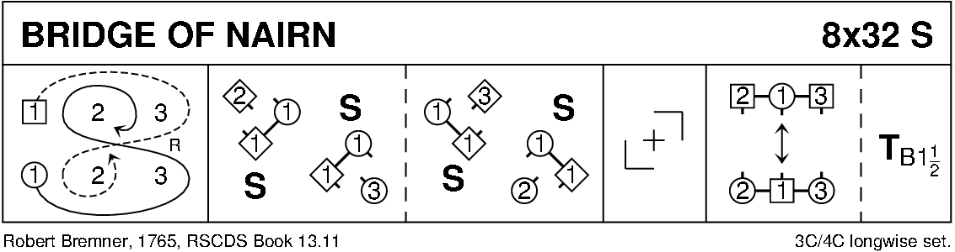

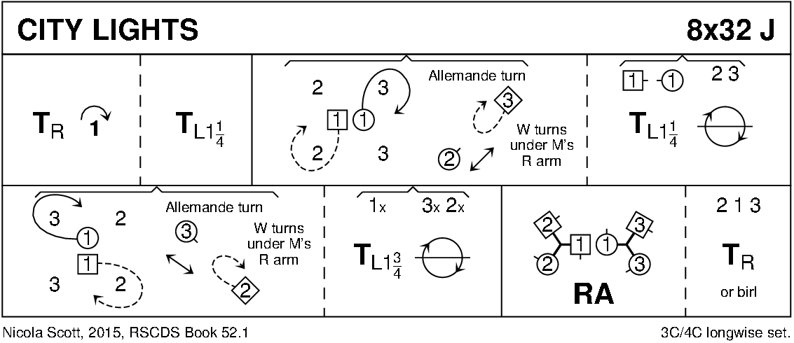

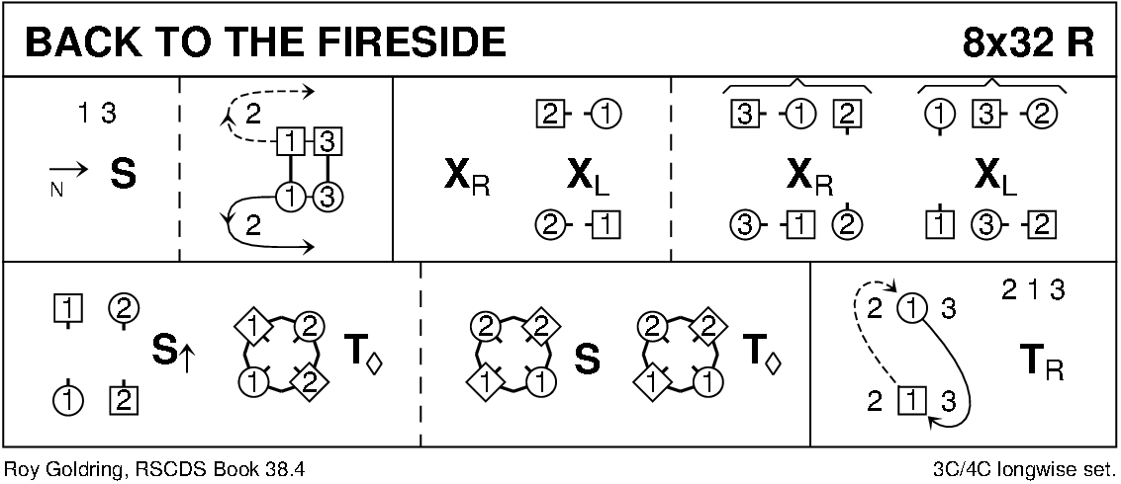

Interval

**Perth and Perthshire Centenary Jig**

8x40 J Allana Creighton

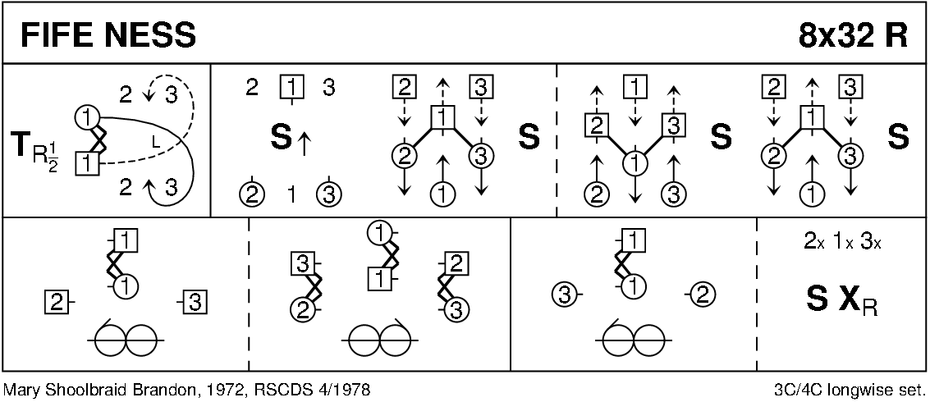

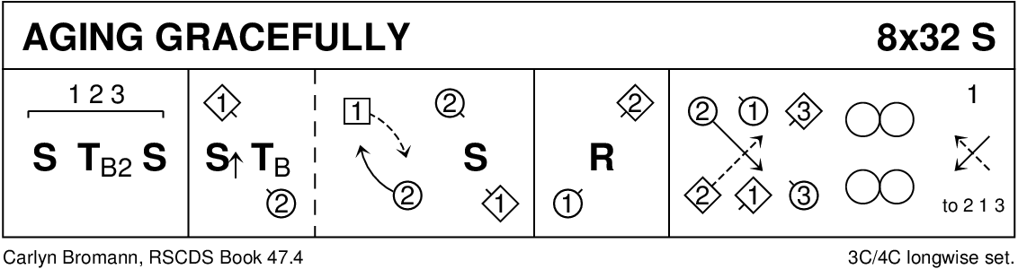

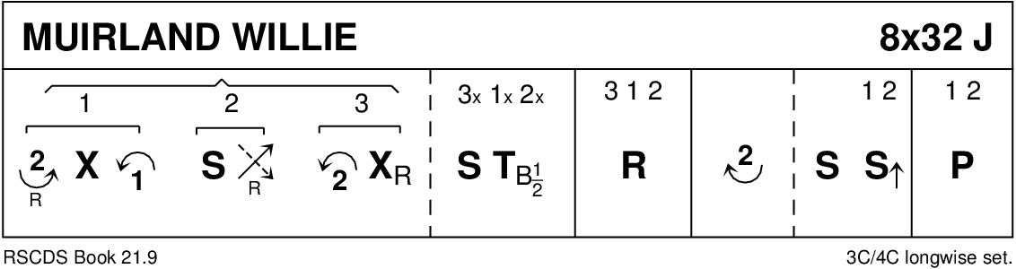

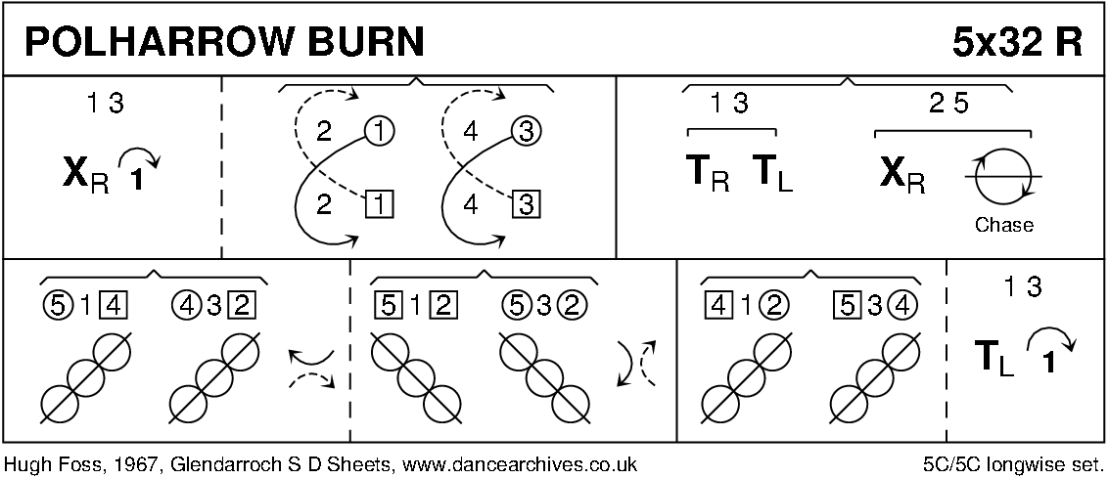

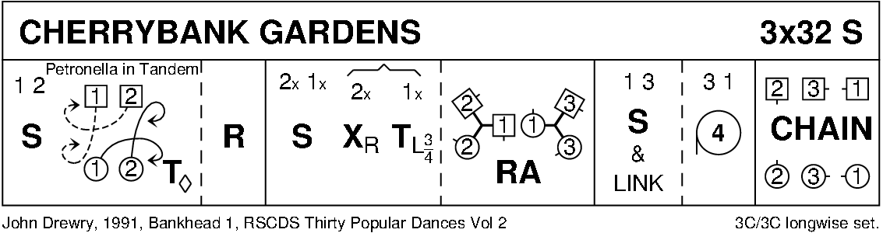

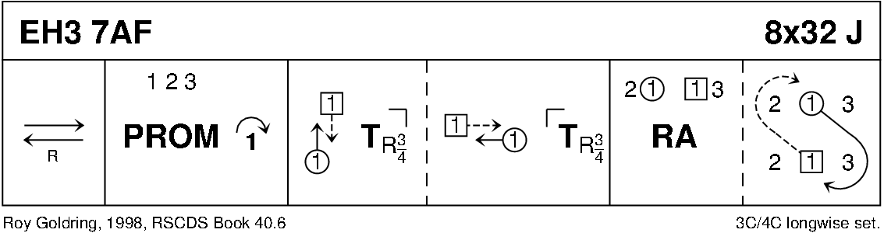

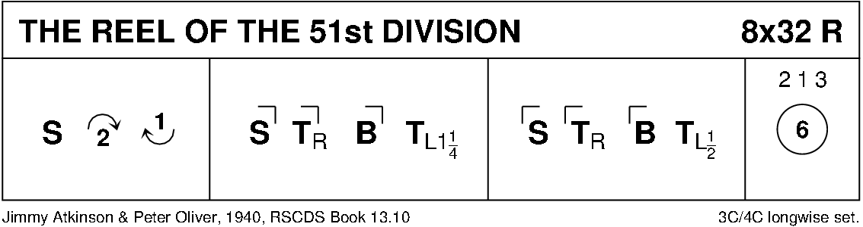

Diagrams – Keith Rose, Bedford RSCDS.