Summer Dance 5 August 2025 June Templeman

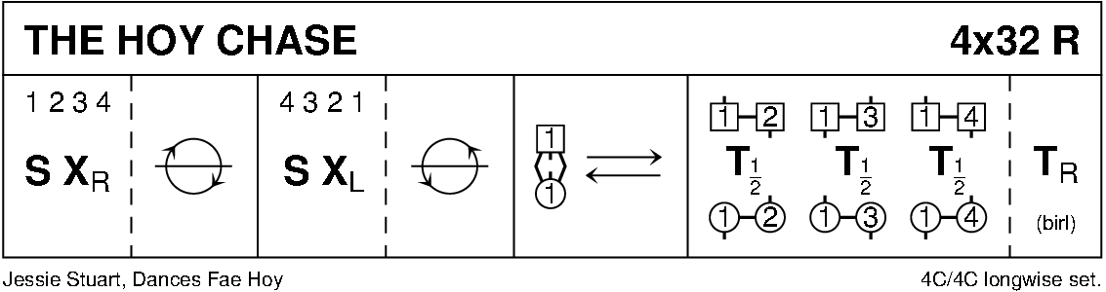

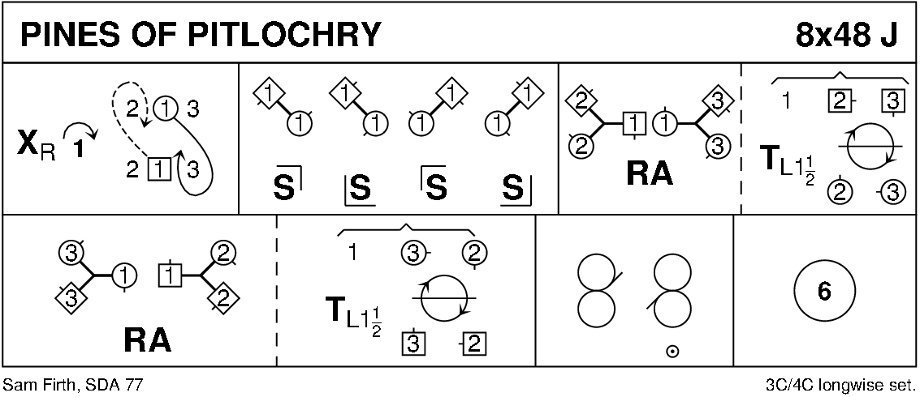

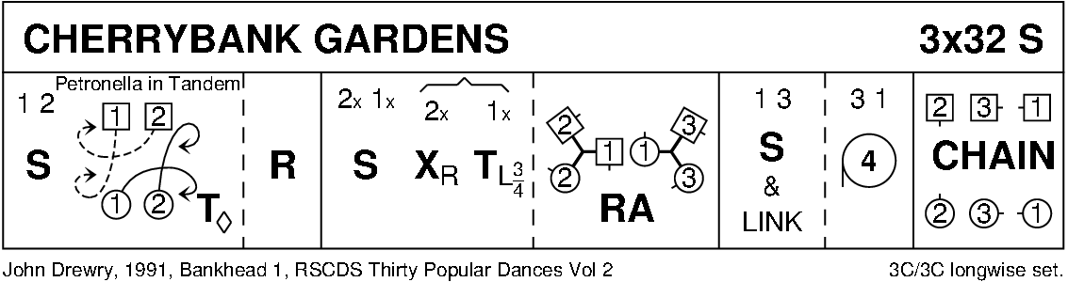

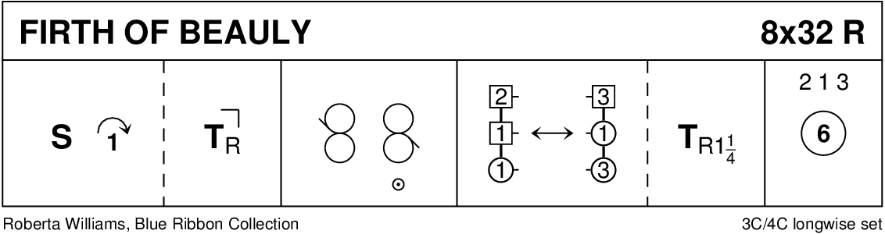

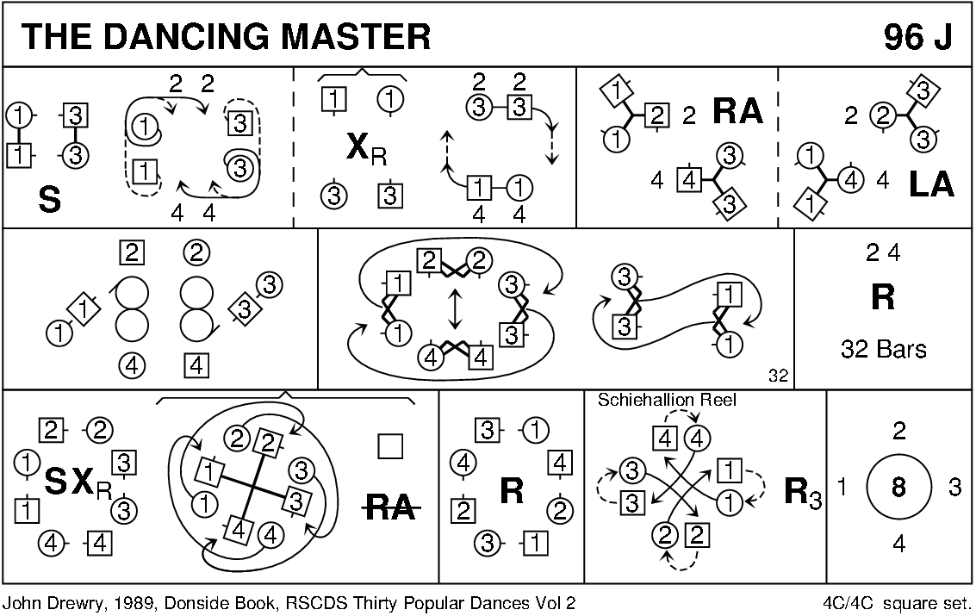

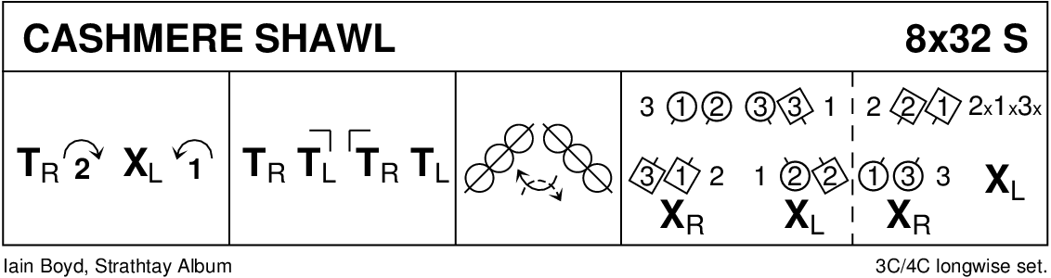

**DUNKELD HOUSE** (J8x32) 3C (4C set) John Drewry Donside Book

1- 8 1s+2s+3s dance reflection reels of 3 on opposite sides 1s ending in 1st place opposite sides  
9-16 1s turn 2s with nearer hand on sides 1½ times, 1s cross to turn (once) 3s on own side (with other hand) 1s end facing 1st corner  
17-24 1s set to 1st corners, pass by the right, set to 2nd corners, pass by the right to BtoB position in centre Man facing up and Lady down  
25-32 1M dances up and casts to 2nd place own side as 1L dances down and casts up to 2nd place own side, 1L dances RH across with 2s and 1M with 3s.

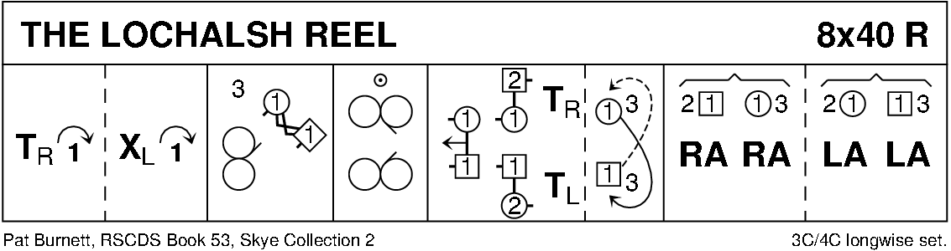

Interval

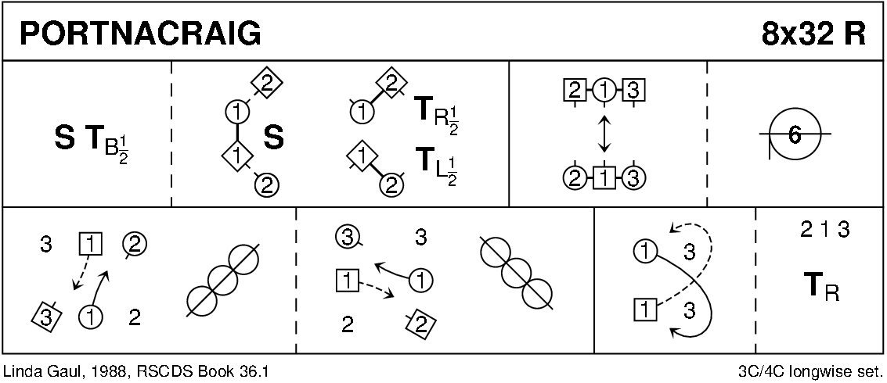

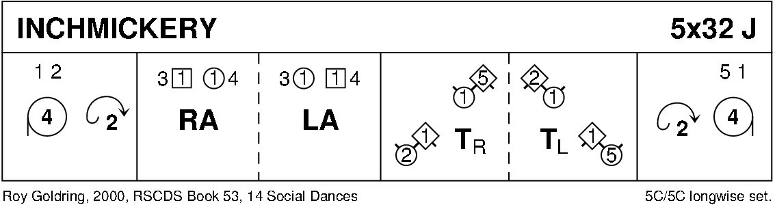

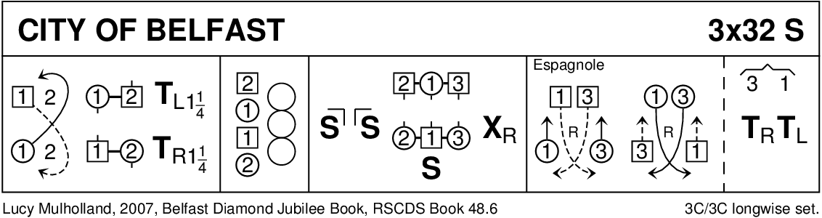

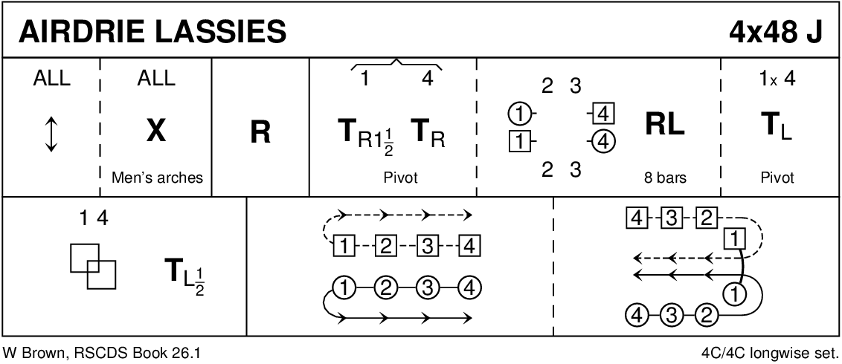

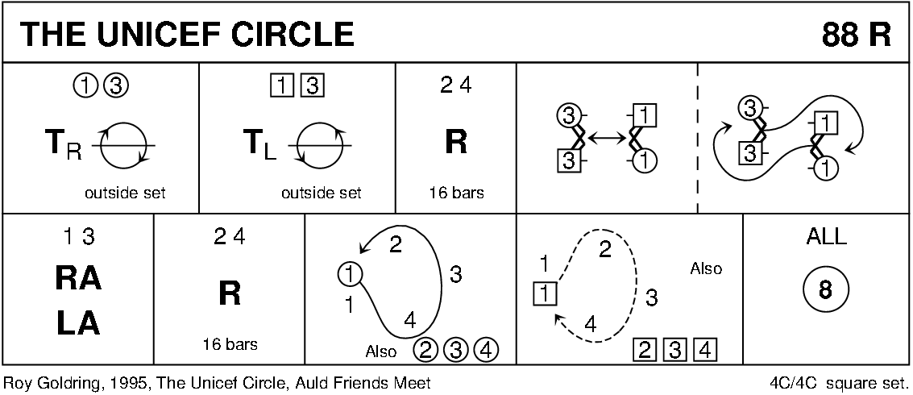

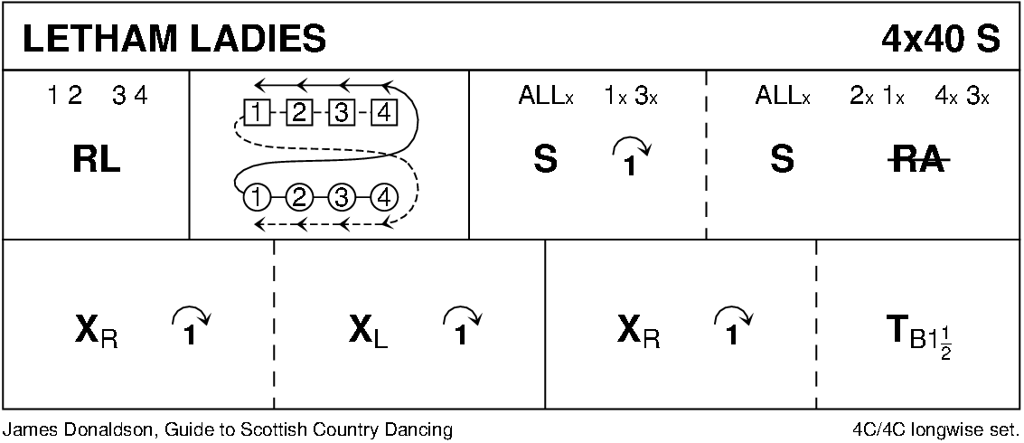

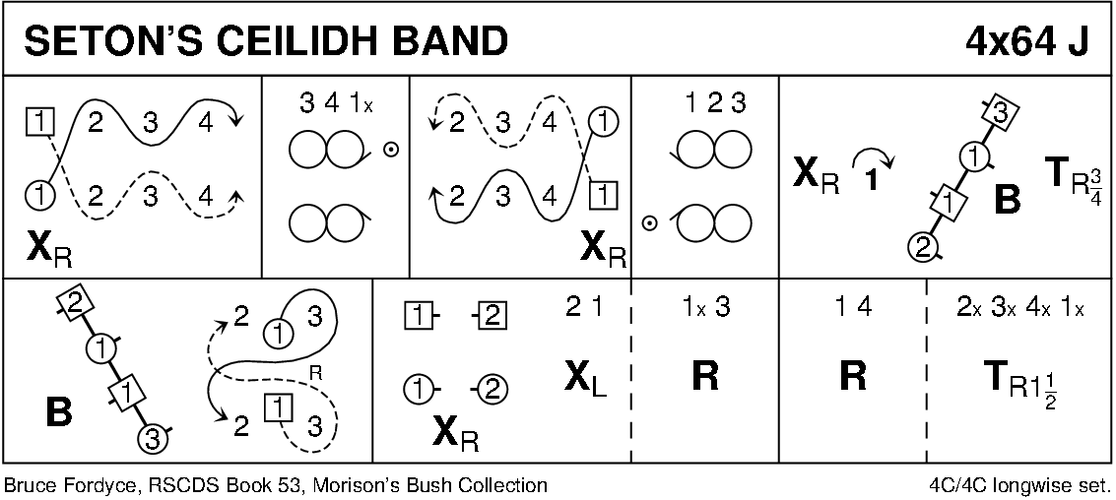

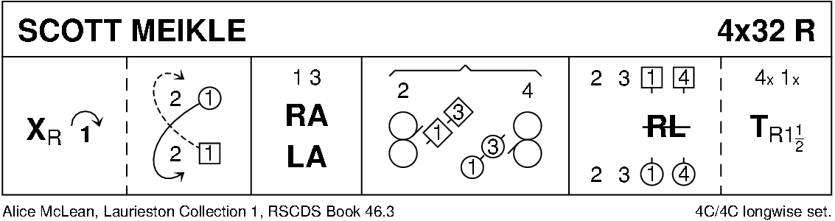

Diagrams -Keith Rose, Bedford RSCDS