Summer Dance 29 July 2025 Linda Magill

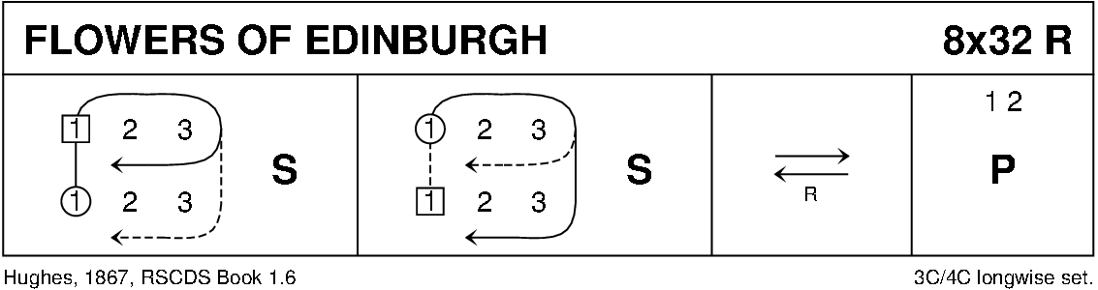

Kinnoull Hill Jig 8x32 Bankhead Bk 5

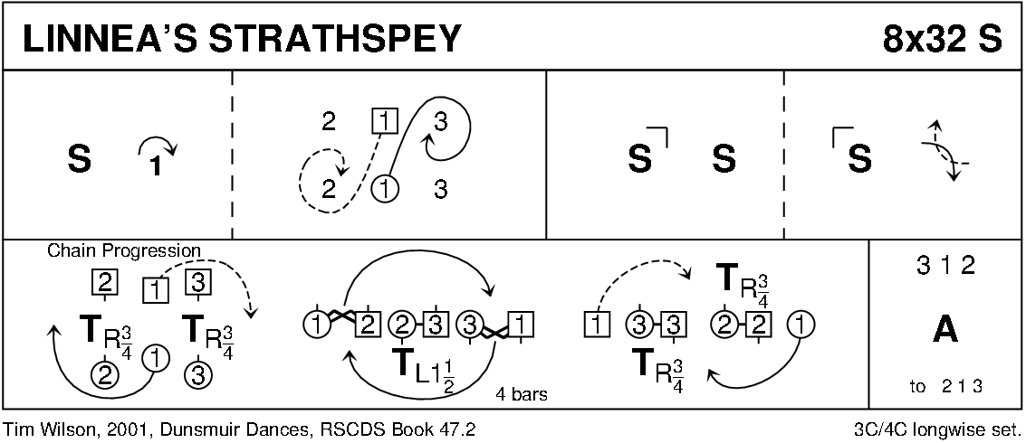

**QUEEN'S BRIDGE** (R4x40) 4C set Anne Wishart and John Williamson RSCDS Perth 1960

1. 8 All dance reels of 4 on sides  
   9-16 All set (take hands on sides) and cross RH, all set and cross back RH  
   17-24 1s cross RH below 2s, cast to between 3s and 4s, cross LH and cast to 4th place own side (2s+3s+4s take hands bars 23-24 to step up)  
   25-32 2s+3s also 4s+1s dance RH across and LH back. 1s remain in middle facing up  
   33-40 1s dance up to top (2 bars), set, then cast to 4th place while 2s+3s+4s dance down on sidelines (2 steps), set, turn RH and dance up to places nearer hands joined (2 steps) 2341

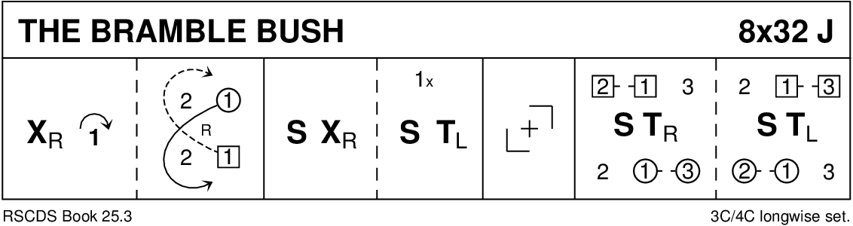

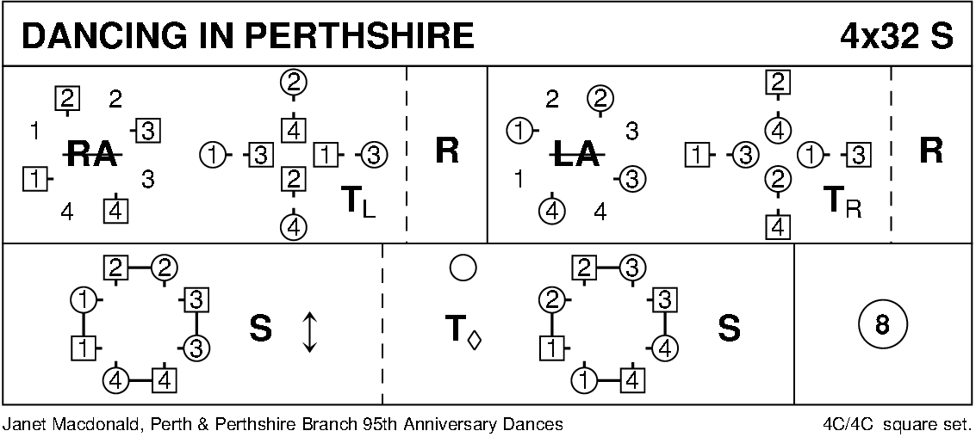

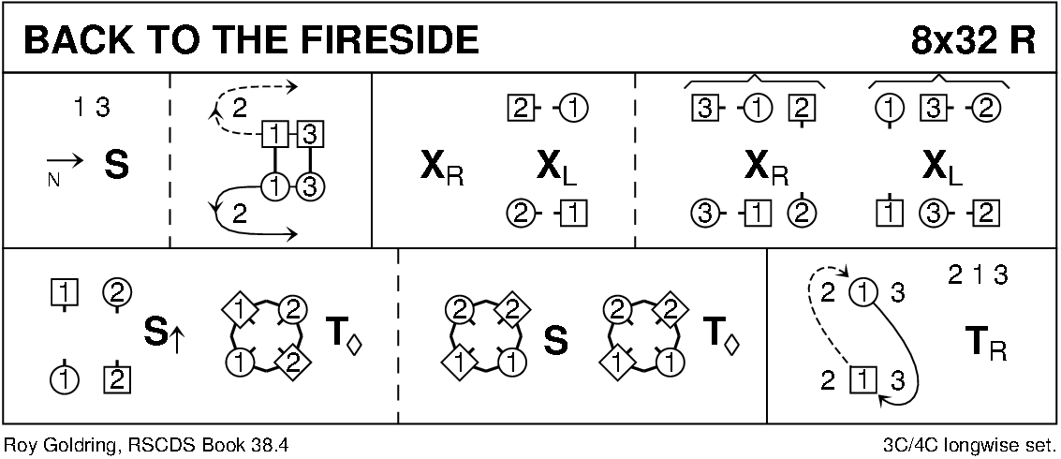

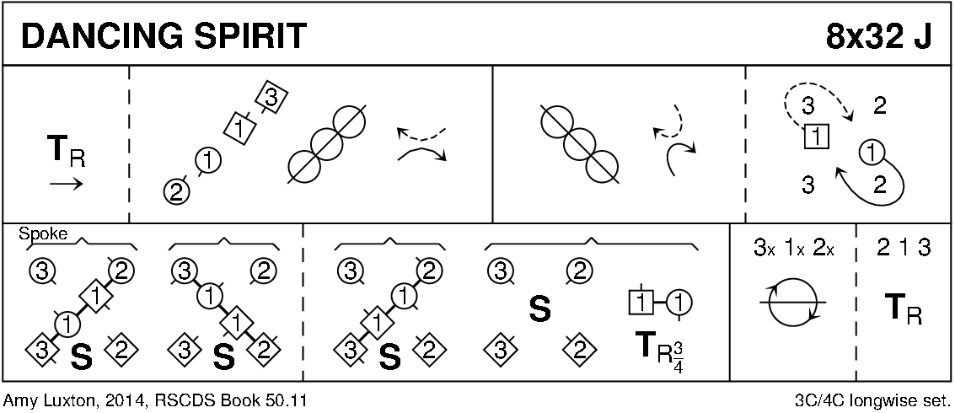

Interval

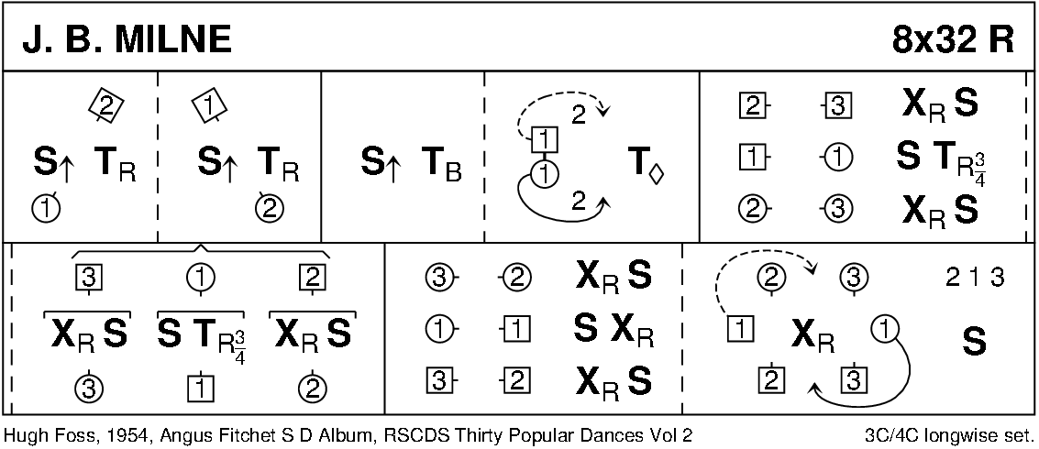

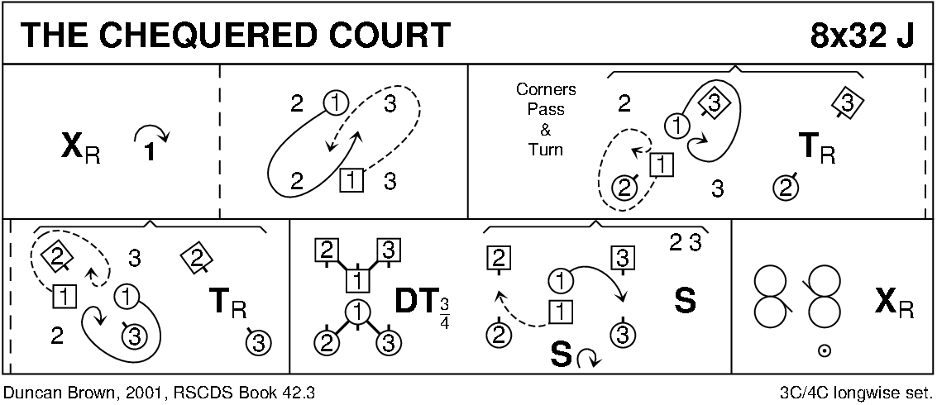

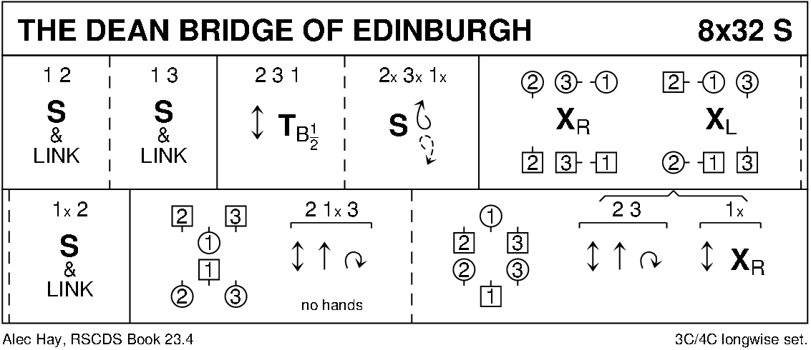

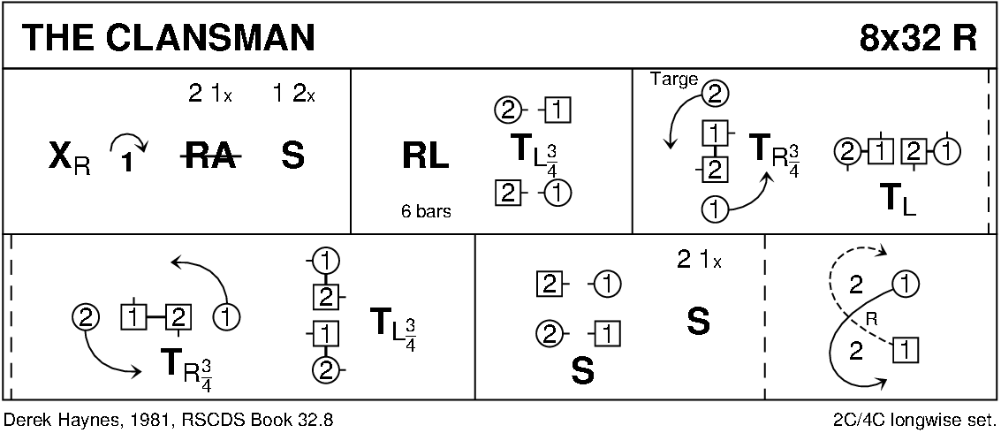

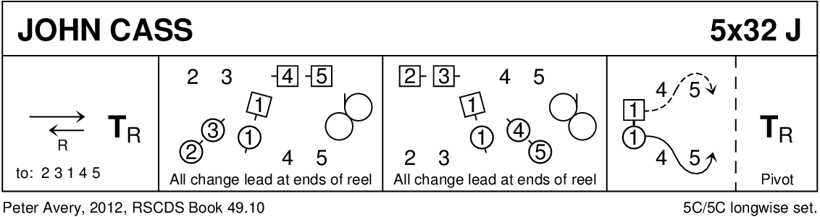

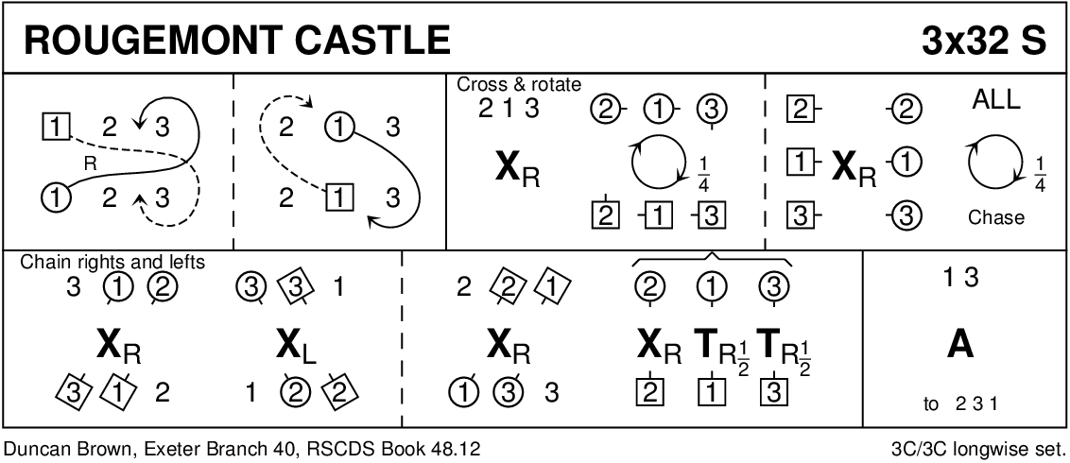

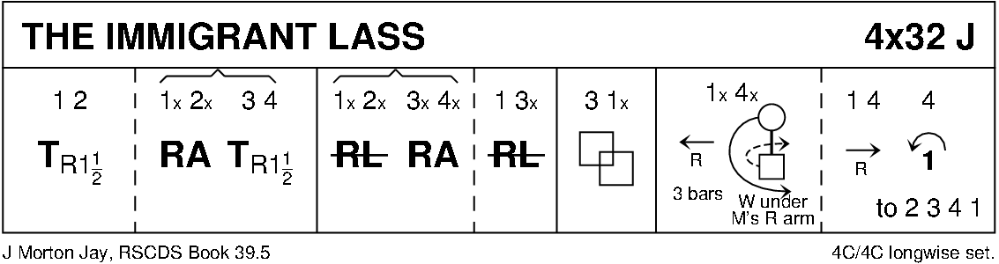

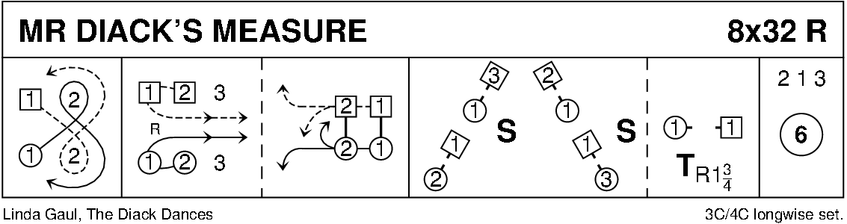

Diagrams -Keith Rose, Bedford RSCDS