Summer Dance 26 August 2025

Margaret Breckenridge

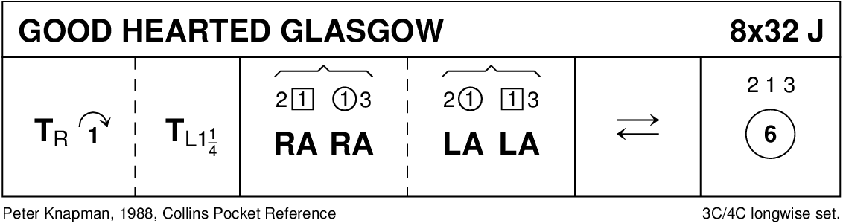

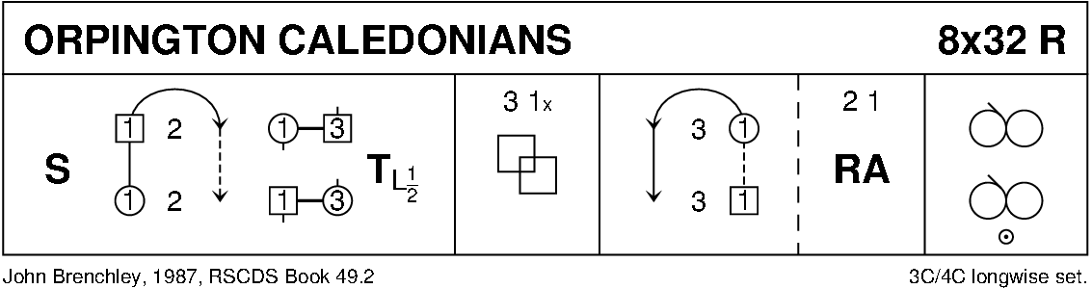

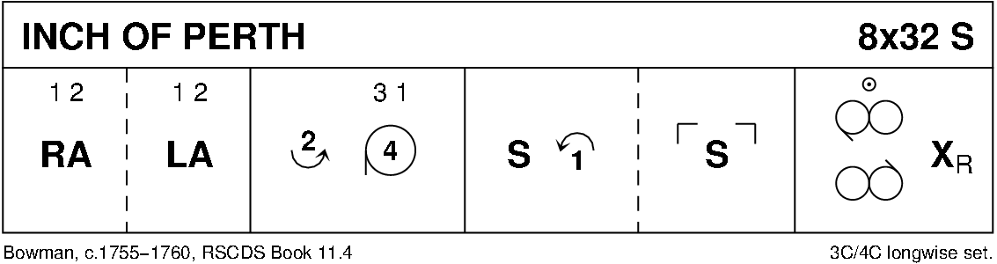

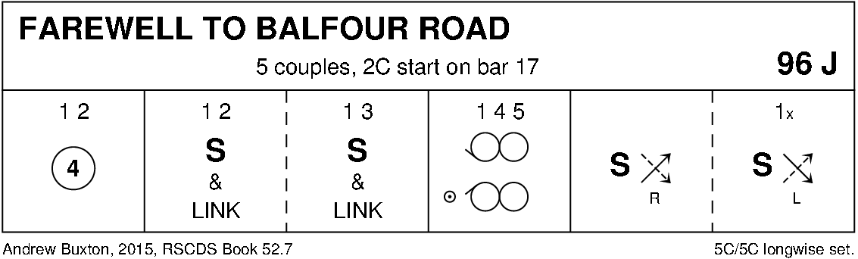

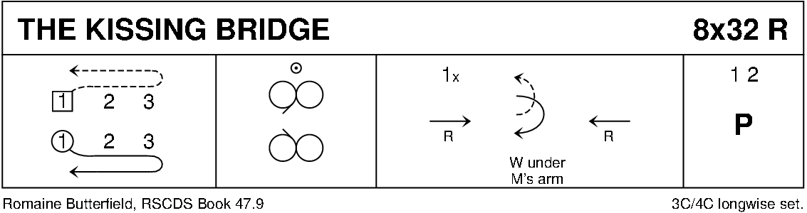

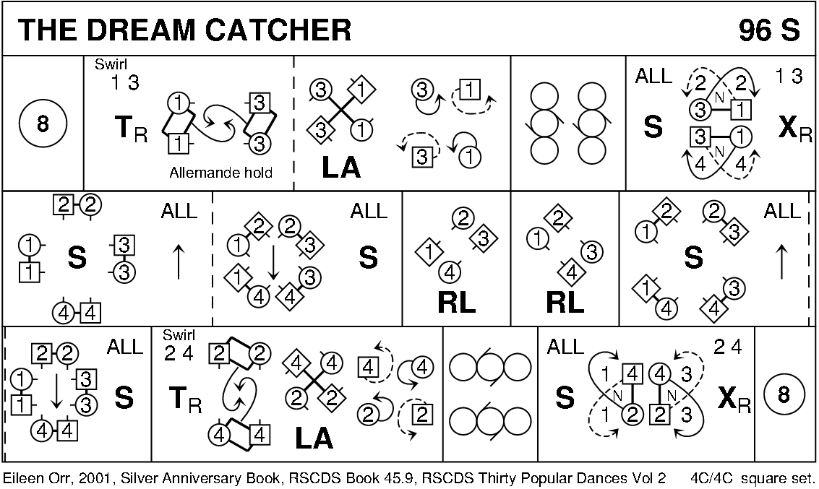

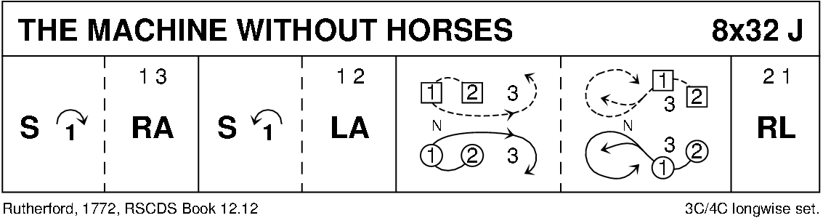

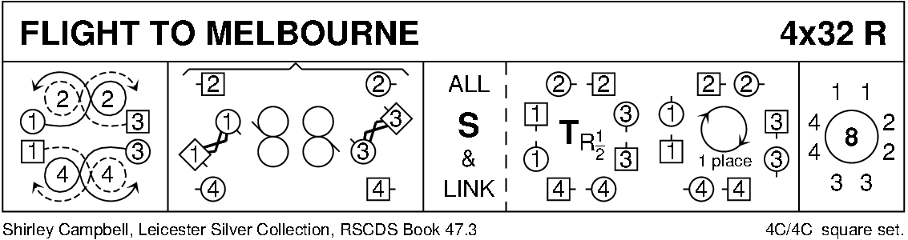

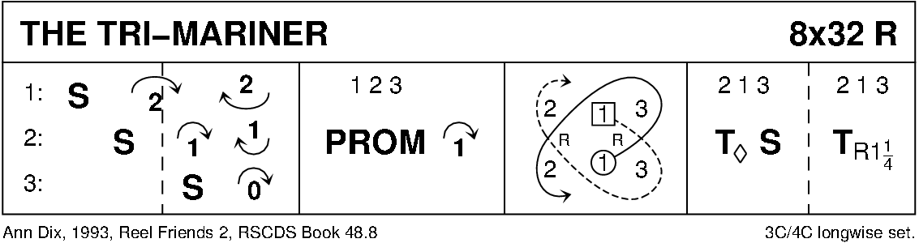

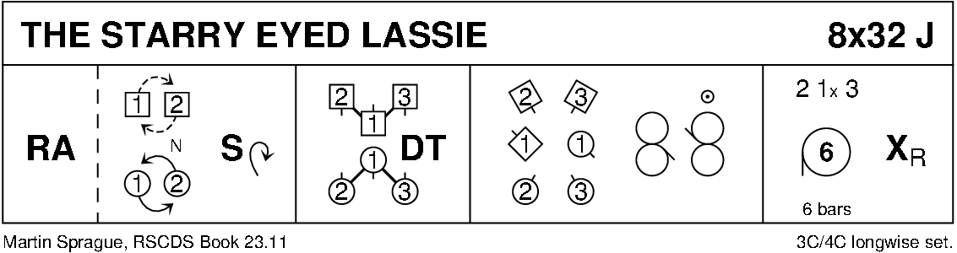

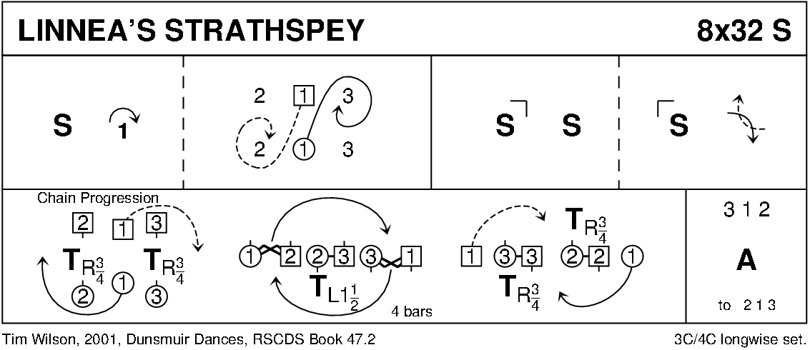

**Stanley Mill**

4x32R Perth Bk

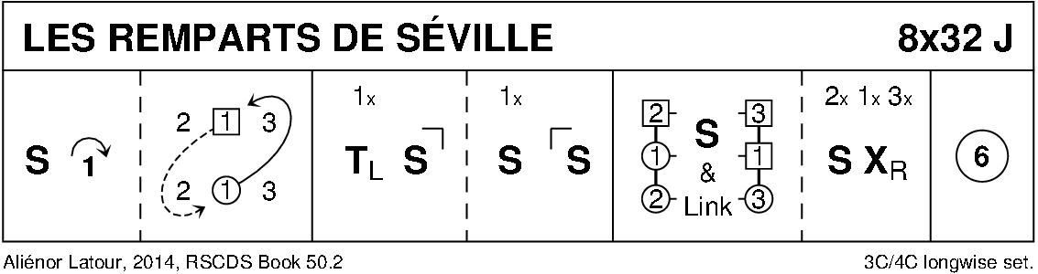

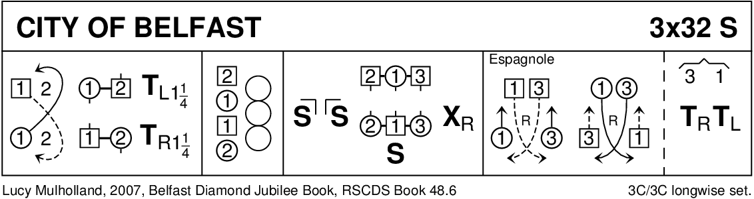

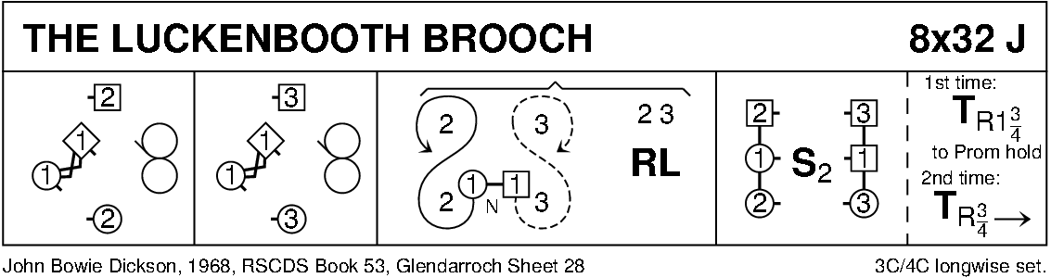

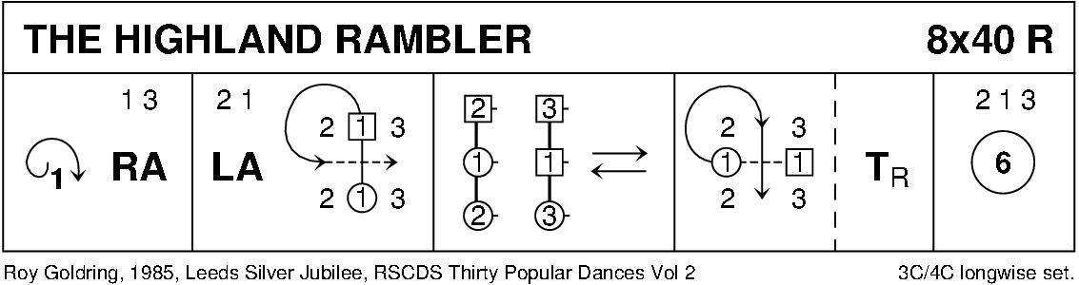

Diagrams -Keith Rose, Bedford RSCDS.