Summer Dance 15 July 2025 Fiona Goudie

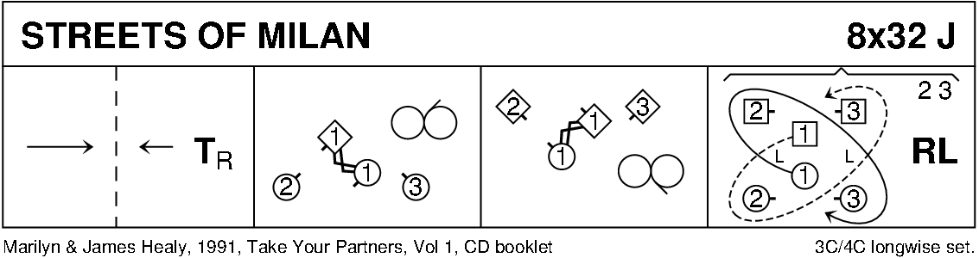

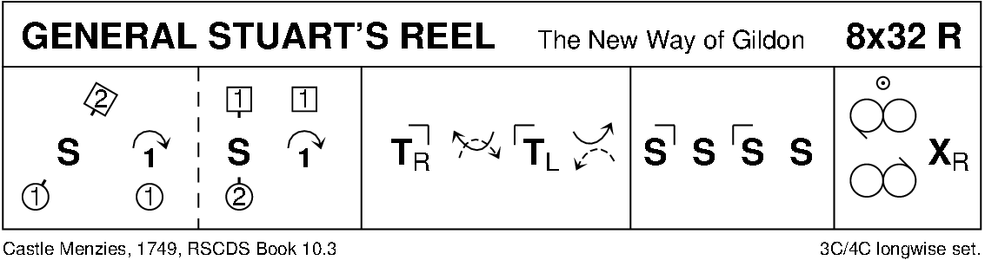

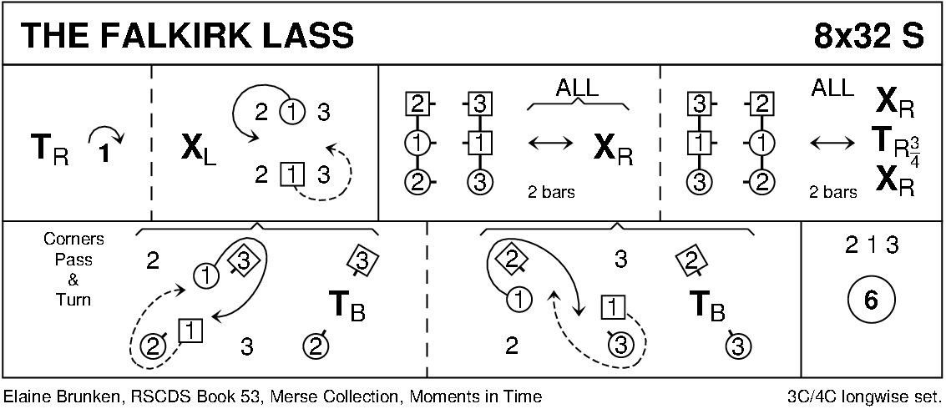

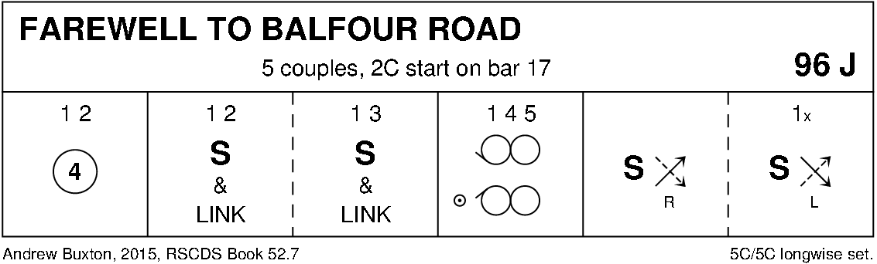

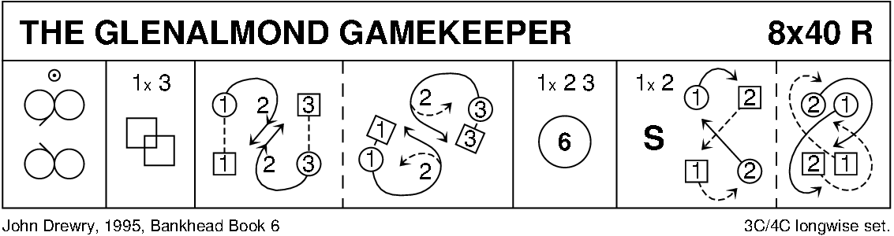

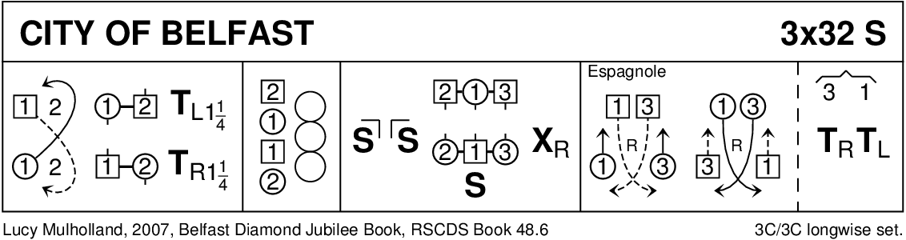

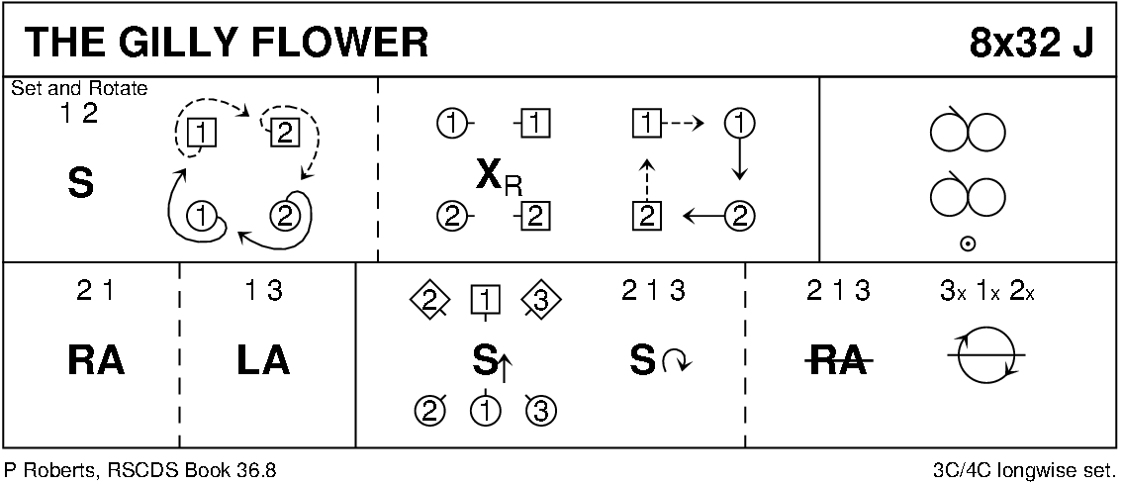

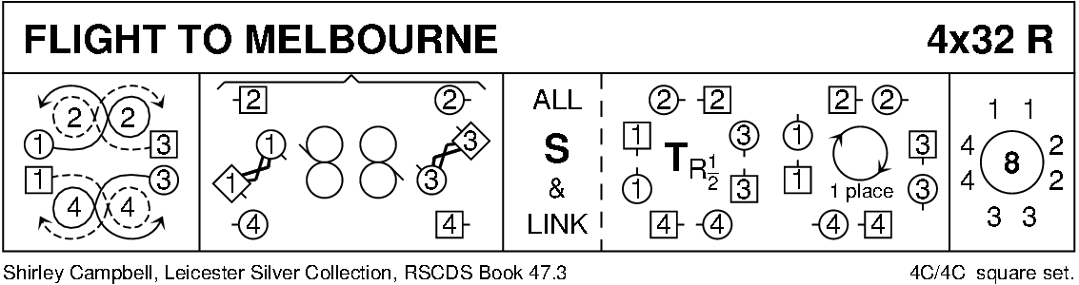

Interval

Diagrams - Keith Rose, Bedford RSCDS.

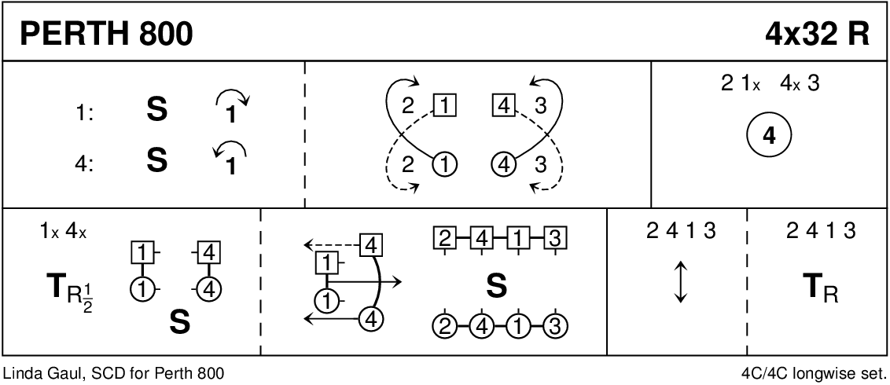

**HIGHLAND GATEWAY** (J8x32) 3C (4C set) Rhoda Purcell Perth 95th Anniversary

1- 8 1s clap and cross passing RSh, cast (2s step up); 1s dance ½ Fig of 8 down round 3s  
9-16 2s+1s+3s dance mirror reels of 3 on sides (1s in/up, 2s out/down, 3s out/up) 2s and 3s curve into place  
17-24 1s dance DoSiDo; 2s+1s+3s dance RSh round partners and back to place  
25-28 All chase clockwise into lines of 3 across, all change places up & down passing RS with partner  
29-32 All chase clockwise to own sides, 2L followed by 1L and 3L cast up while 3M followed by 1M and 2M cast off. 213

