TUESDAY 27 AUGUST 2024 RDMI SCONE 7.30
SANDY NIXON MARGARET BRECKENRIDGE
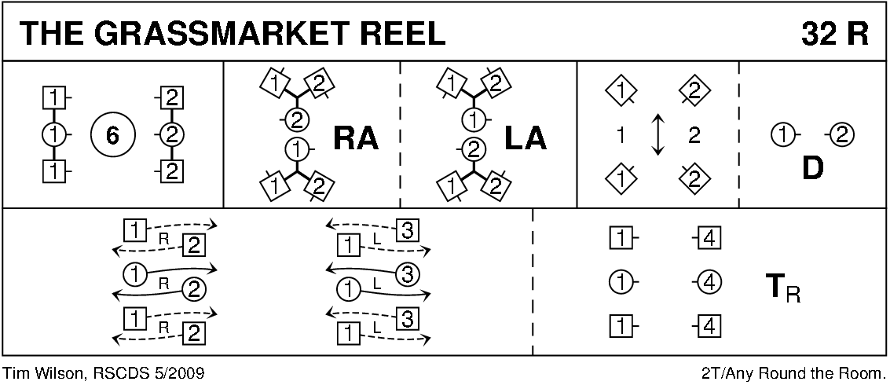
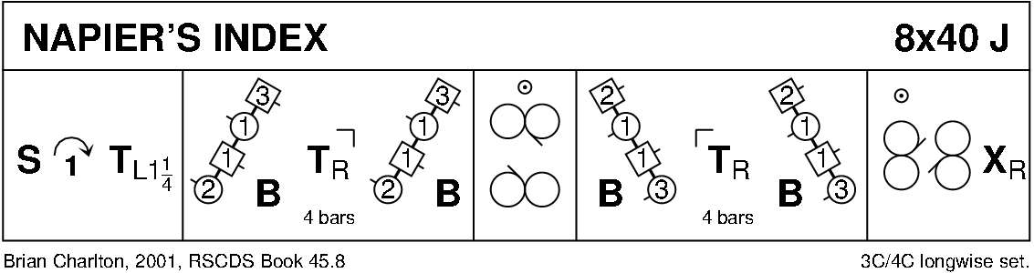
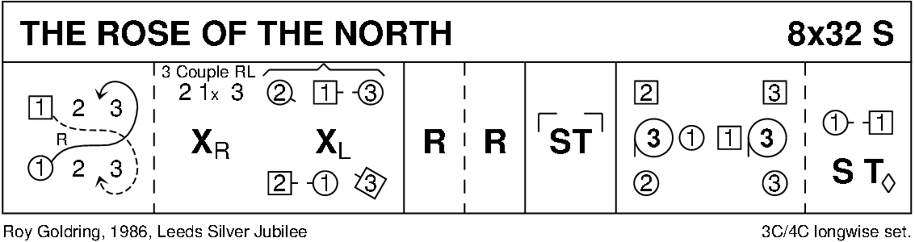
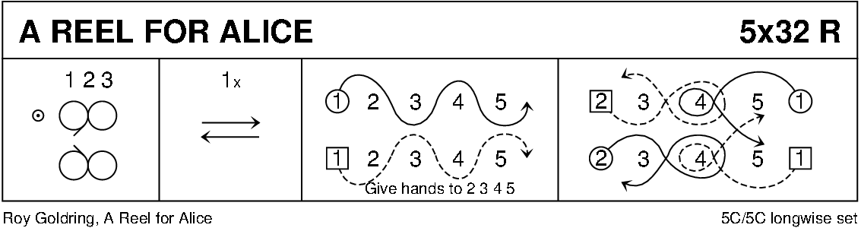
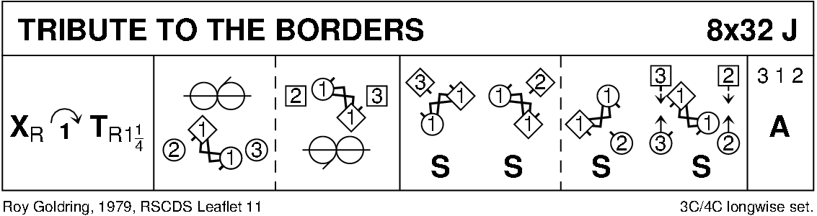
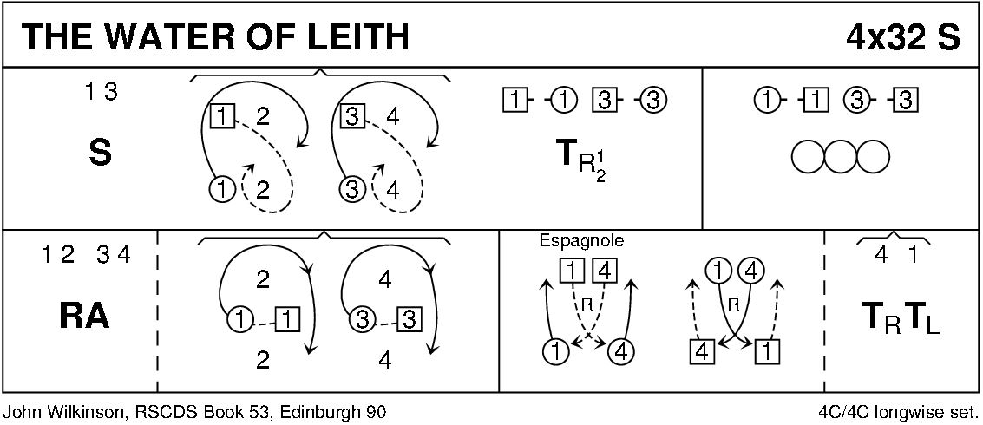
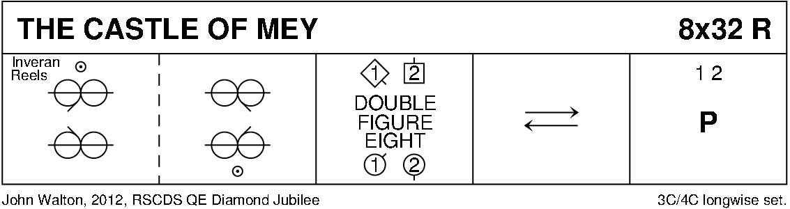
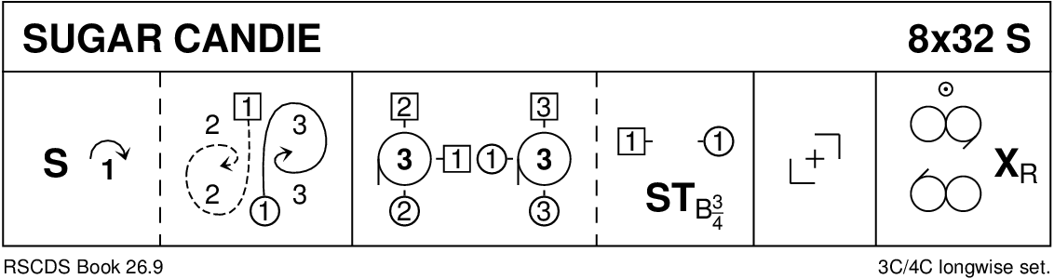
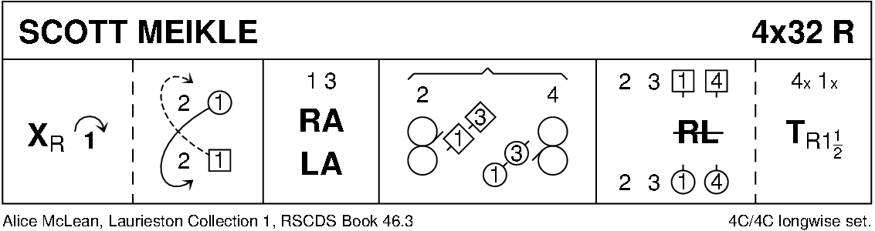
INTERVAL
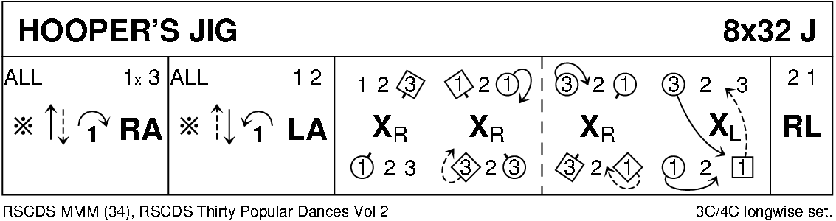
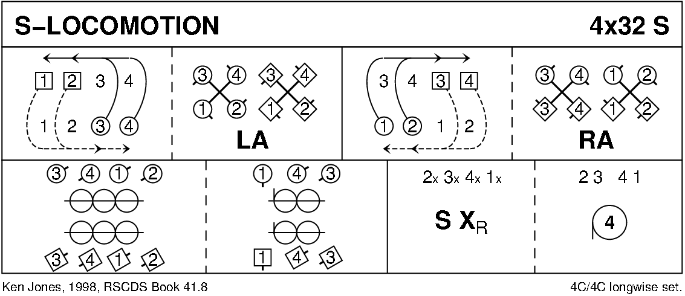
THE CITY OF PRESTON REEL (R8x32) 3C (4C set) Lavinia Morris Ribble Valley Book
1- 8 1s cross RH and cast (2s step up); 1s cross LH and cast to their left (1M down, 1L up) to end facing 1st corners
9-16 1s dance reels of 3 across (RSh to 1st corner). End 1L between 2s facing down, 1M between 3s facing up
17-24 Lines of 3 across advance and retire; 1s cross RH (up/down) and cast to their right. 2(1)3
25-32 2s+1s+3s advance and retire; all set and 1s cross RH to 2nd place own side
(MINICRIB. Dance crib compiled by Charles Upton, Deeside Caledonian Society, and his successors)
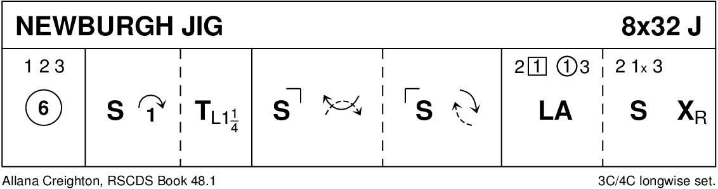
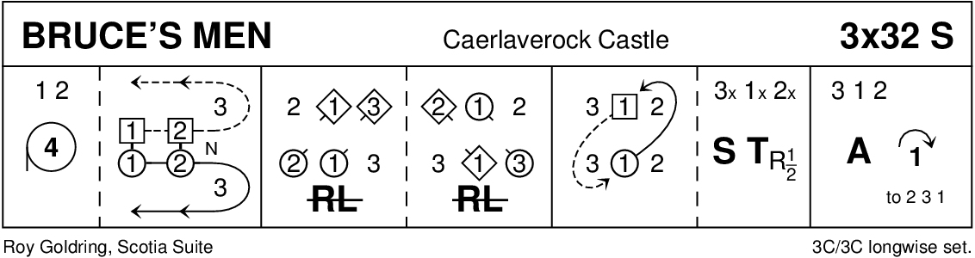
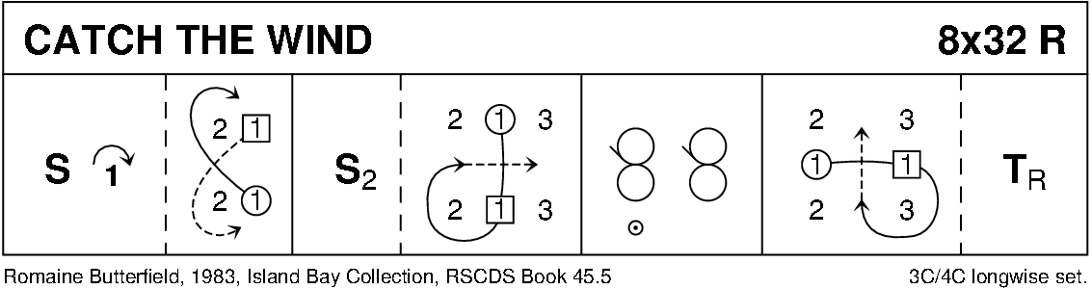
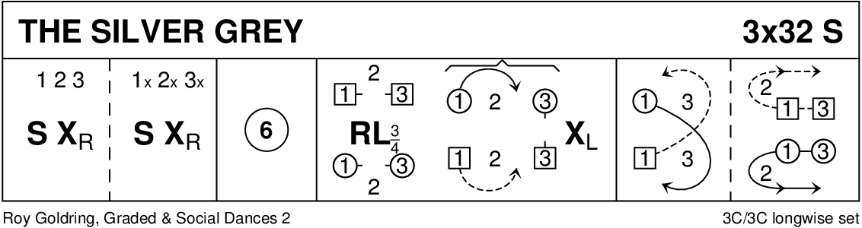
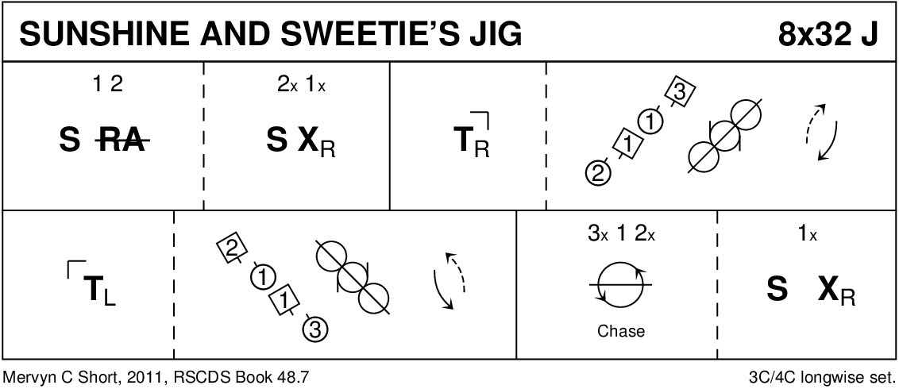
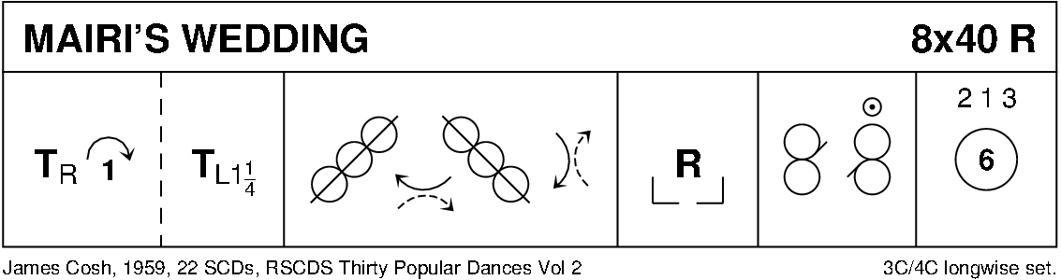
DIAGRAMS CURTESY OF KEITH ROSE, BEDFORD

