TUESDAY 13 AUGUST 2024 RDMI SCONE 7.30
DAVID OSWALD CAROL BISSET

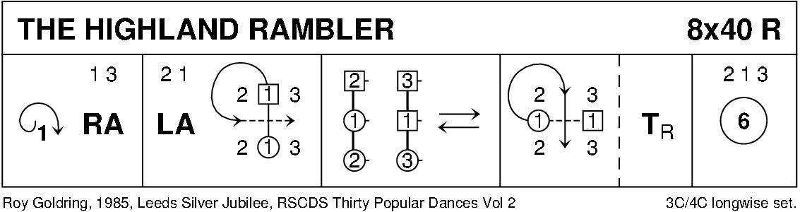
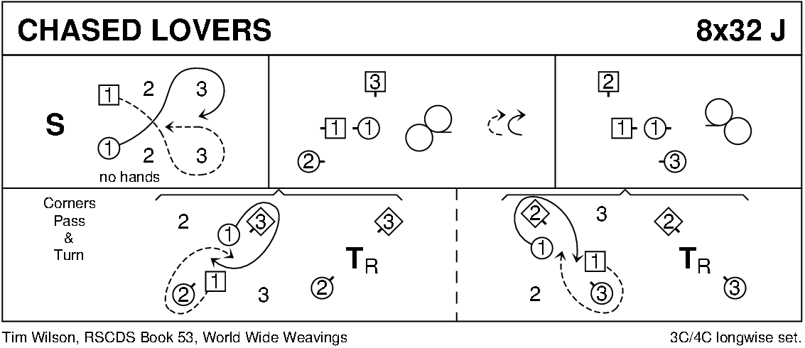
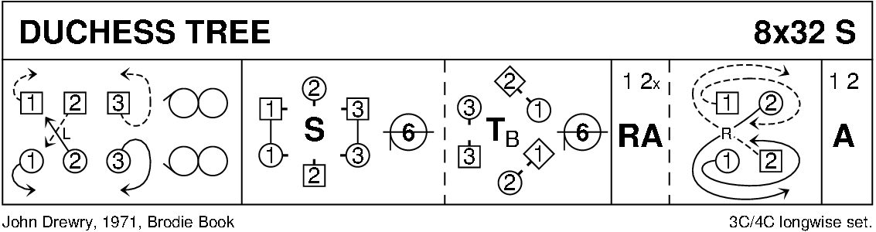
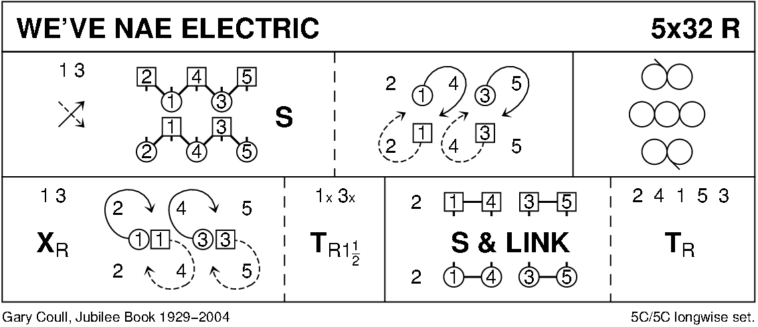
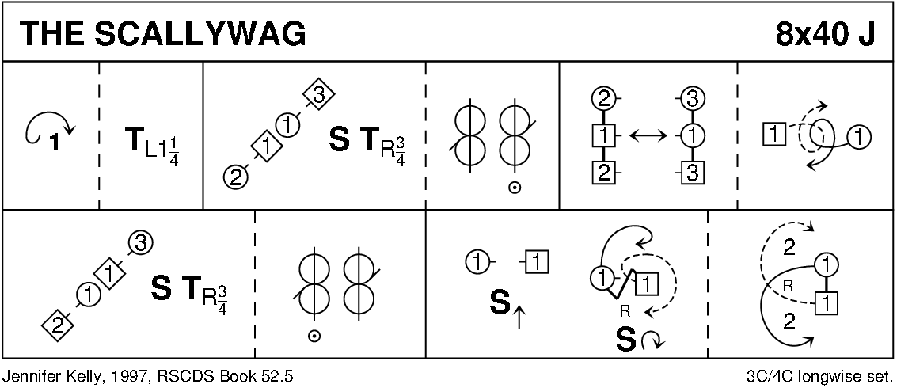
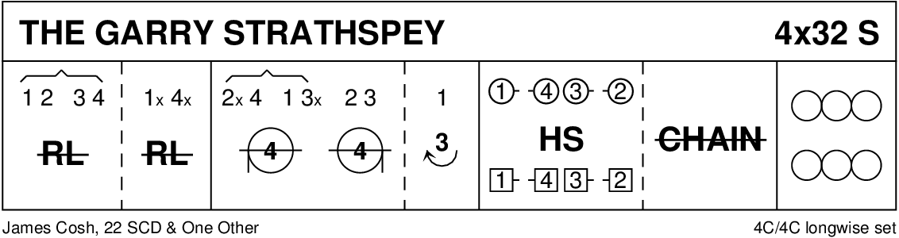
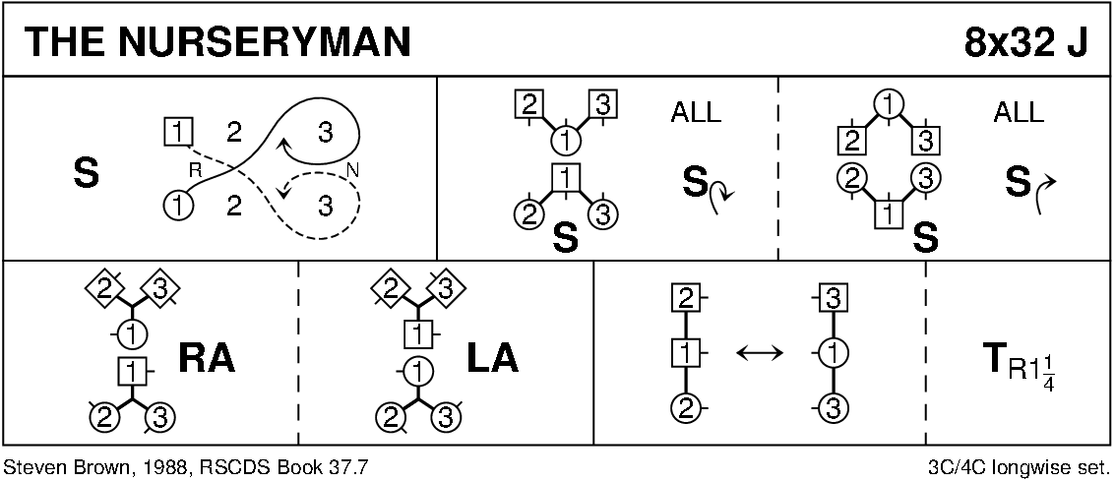
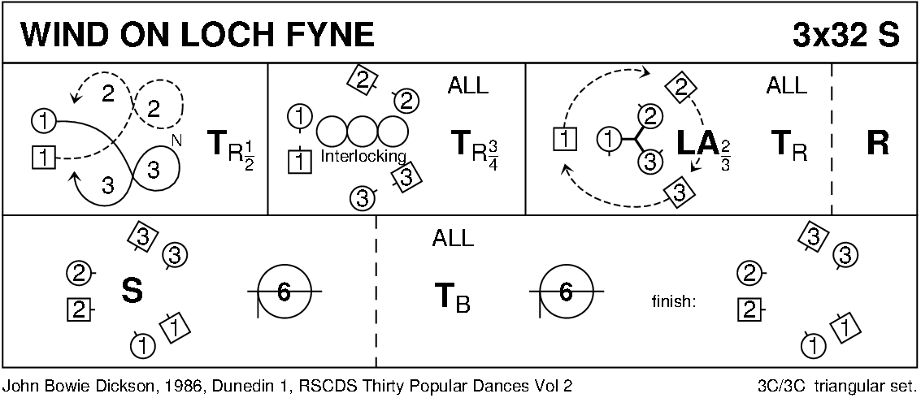
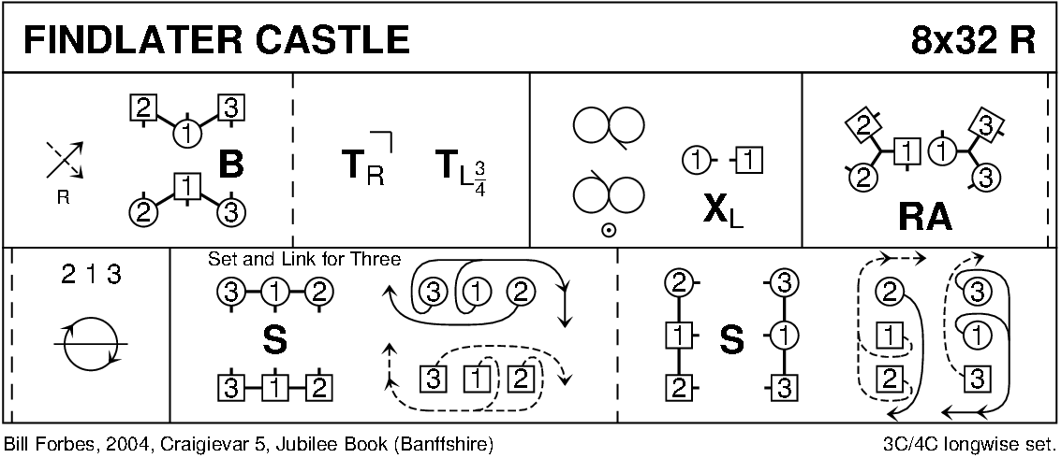
INTERVAL
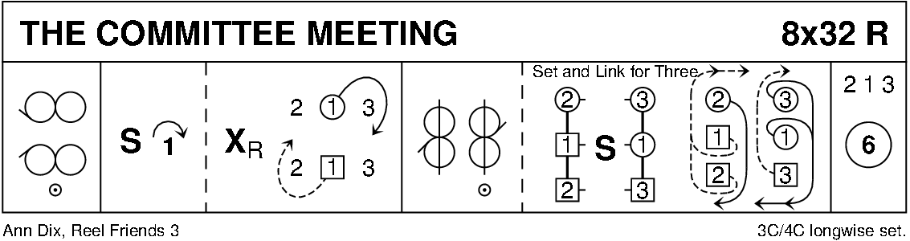
THE EDMONTON SNOWBALL 1 (J4x32) 4C set Enid Fouler Edmonton Workshop 1986
1- 8 1M+2L also 3M+4L advance and retire diagonally and dance DoSiDo diagonally
9-16 1L+2M also 3L+4M repeat
17-20 1s ½ turn RH, 1s+2s dance ½ RH across
21-24 1s ½ turn RH, 1s+3s dance ½ RH across while 2s turn RH once round (4 bars)
25-28 1s ½ turn RH, 1s+4s dance ½ RH across while 2s+3s dance RH across once round
29-32 1s set (4 bars) while 2s+3s+4s set and cross RH. 2341
(MINICRIB. Dance crib compiled by Charles Upton, Deeside Caledonian Society, and his successors)
FAREWELL TO BENBECULA (S3x32) 3C set Deirdrie MacCuish Bark Peat Road and Other Dances
1- 4 1s+2s set, 1s+2s ½ turn partner 2H, finishing in centre, 1s facing down, 2s facing up nearer hands joined
5- 8 1s+2s set advancing to pass other couple LSh and ½ turn partner 2H to own side, 1s facing out. 213
9-16 2s+1s+3s dance 6 bar RSh reels of 3 on sides (1s pass 3rd corner RSh to start), 2s+1s change places (Ladies LH, Men RH). 123
sides facing in
25-32 1s+2s+3s dance the Slip Knot:
25-30 All 3 couples dance first 6 bars of standard 17-24 1s Petronella turn and set; 1s turn 1¼ RH to own Knot. (3)(2)(1)
31-32 1s (at bottom) turn LH to own side while 3s+2s dance ½ LH across to end on own side. 231
(MINICRIB. Dance crib compiled by Charles Upton, Deeside Caledonian Society, and his successors)
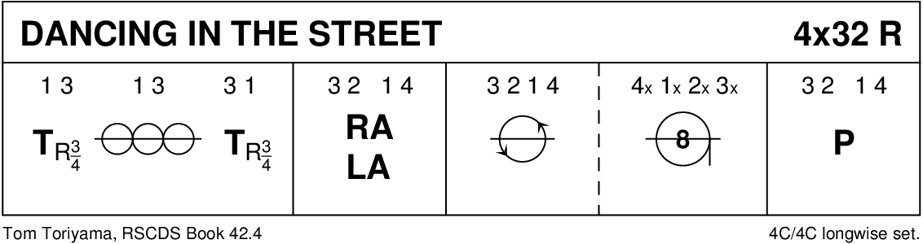
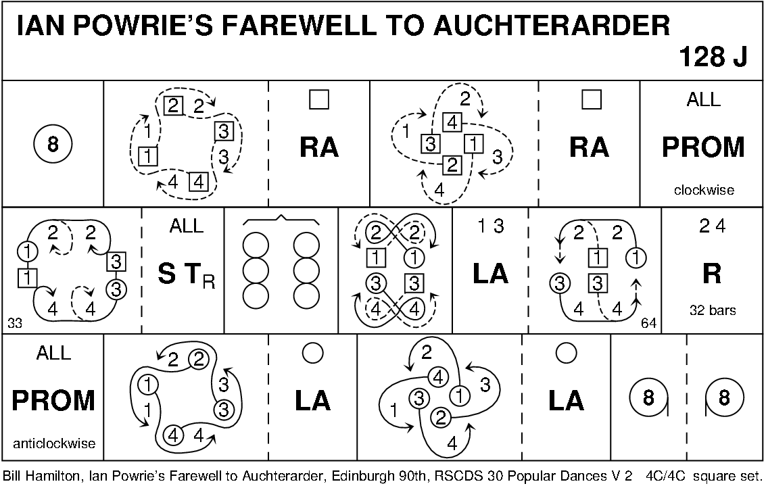
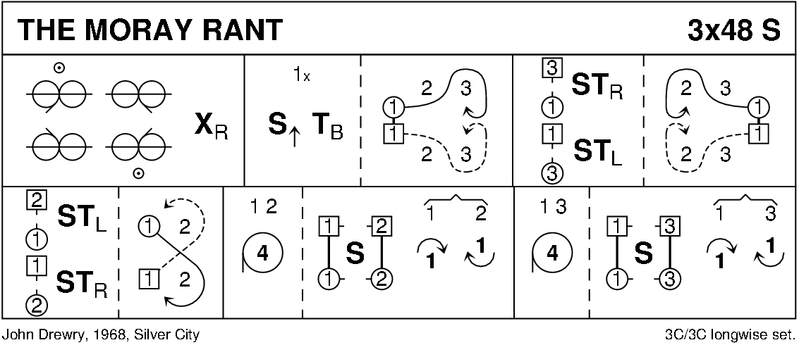
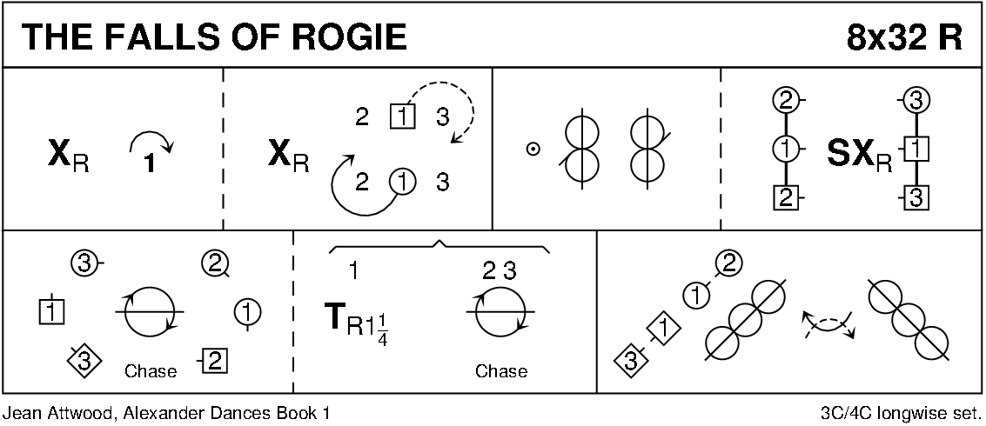
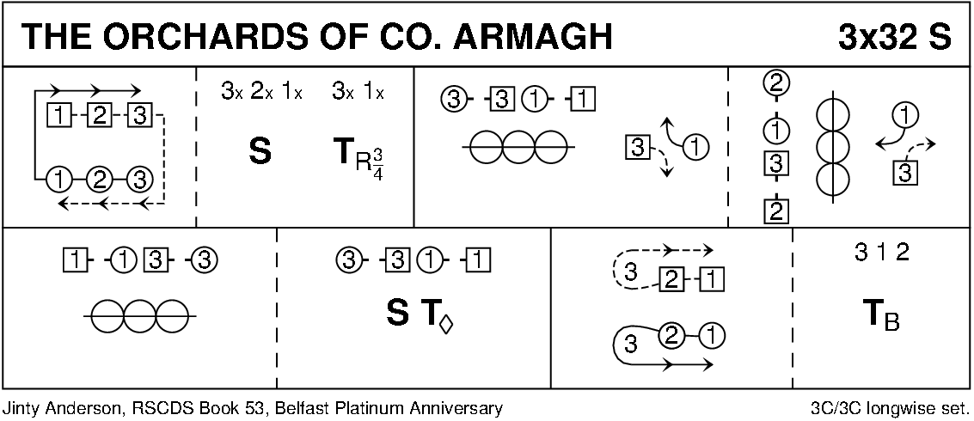
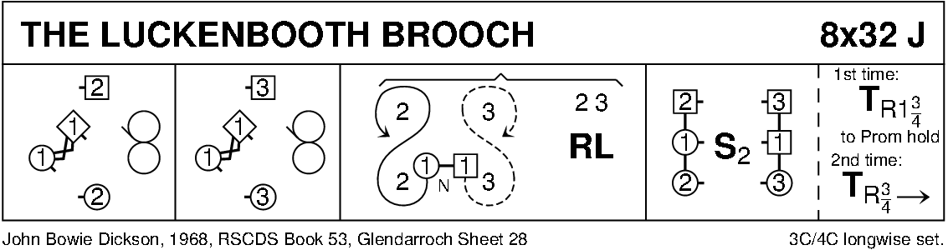
DIAGRAMS CURTESY OF KEITH ROSE , BEDFORD

