TUESDAY 6 AUGUST 2024 RDMI, SCONE 7.30
STEVEN CARCARRY LINDA MAGILL
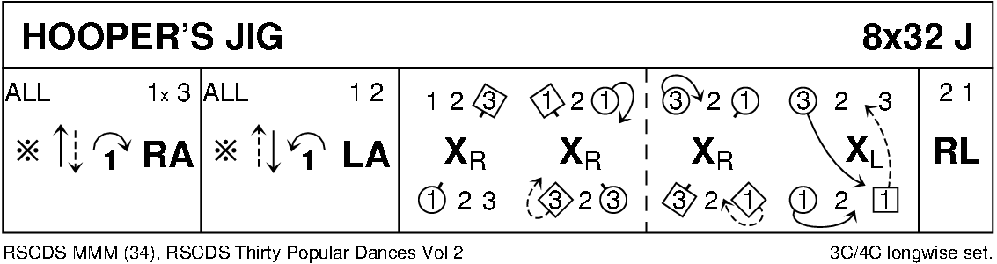
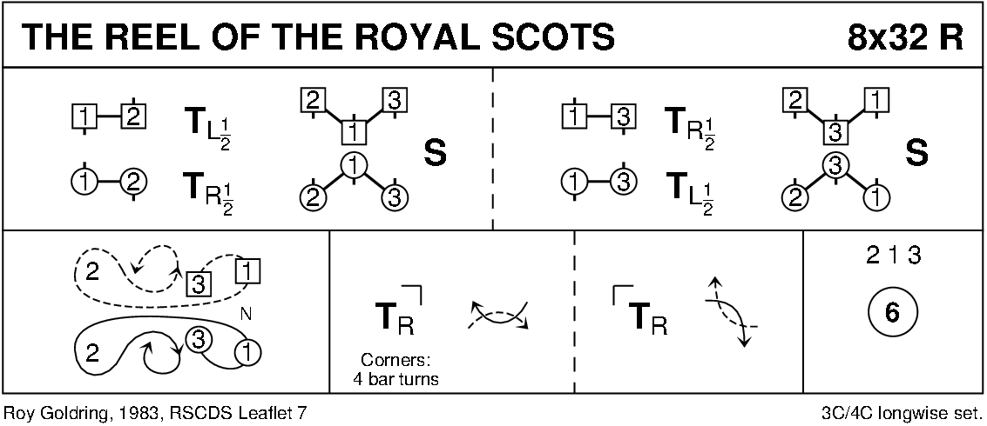
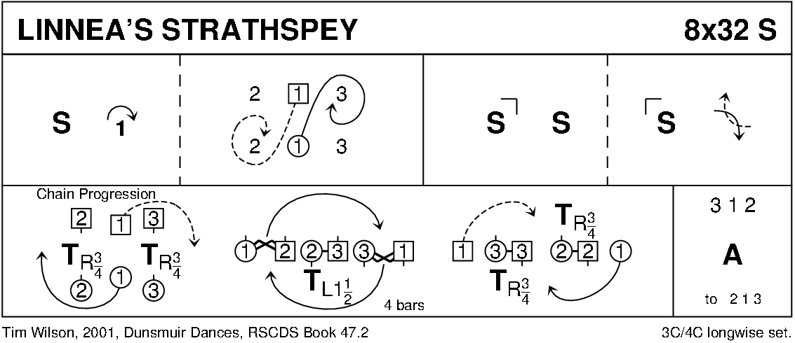
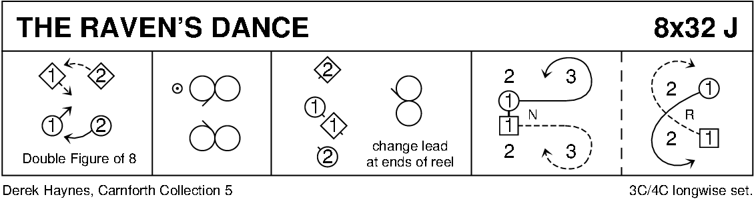
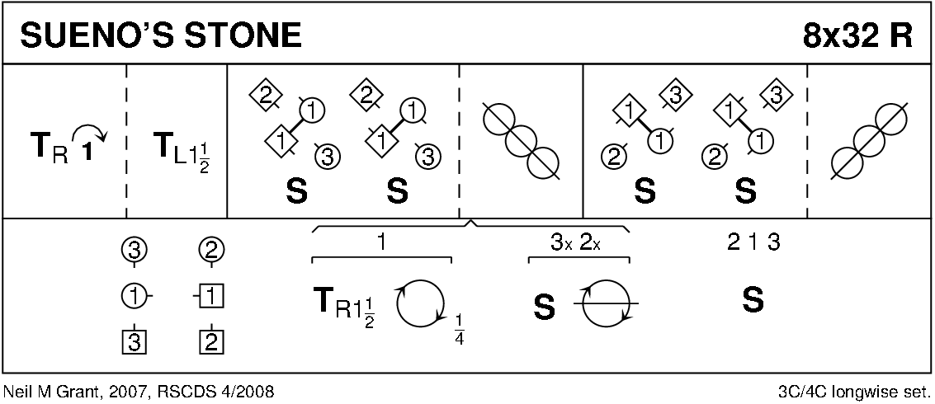
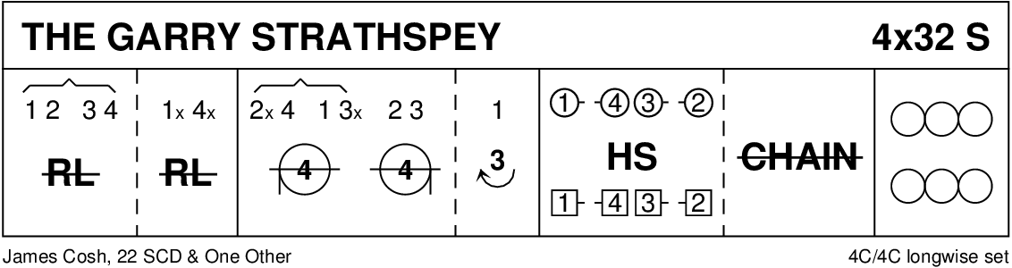
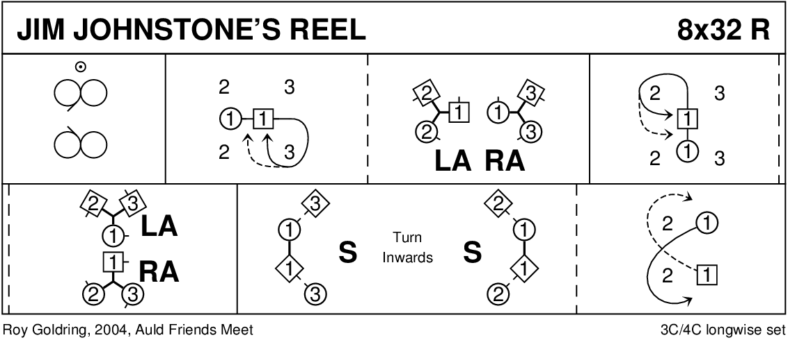
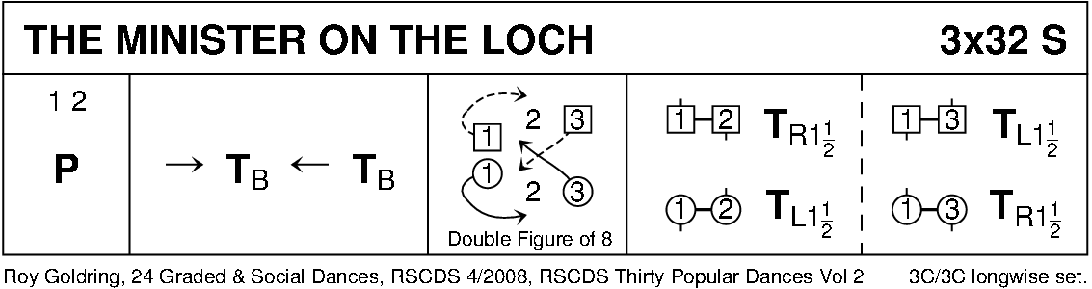
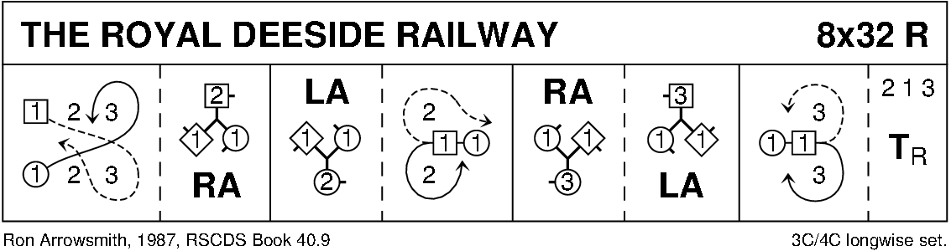
INTERVAL
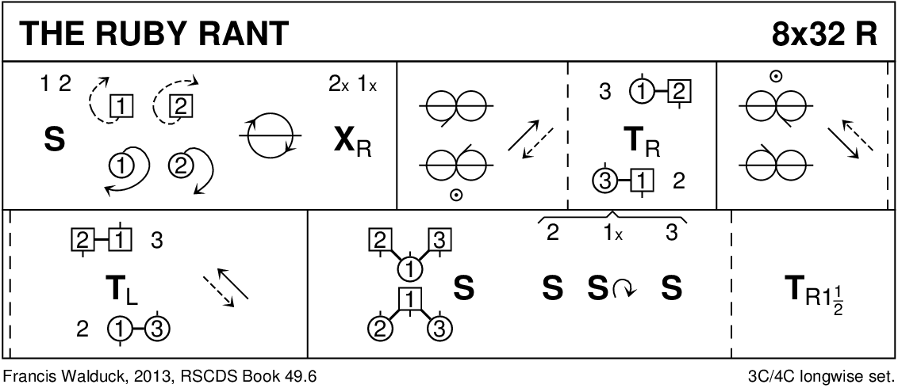
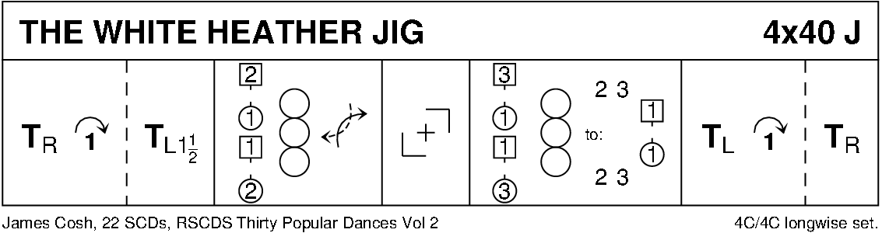
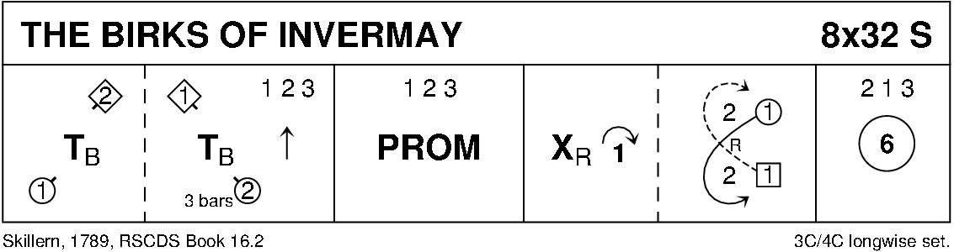
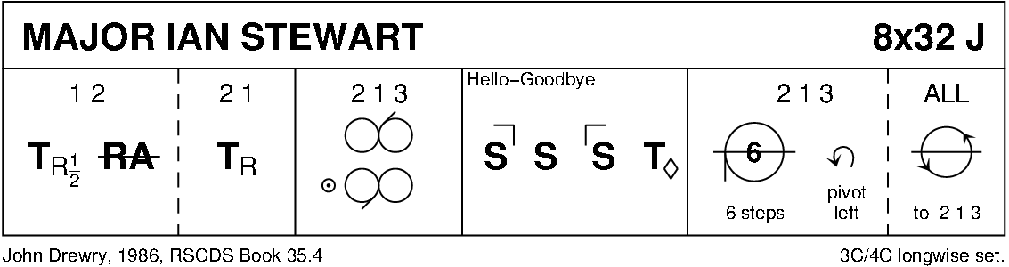
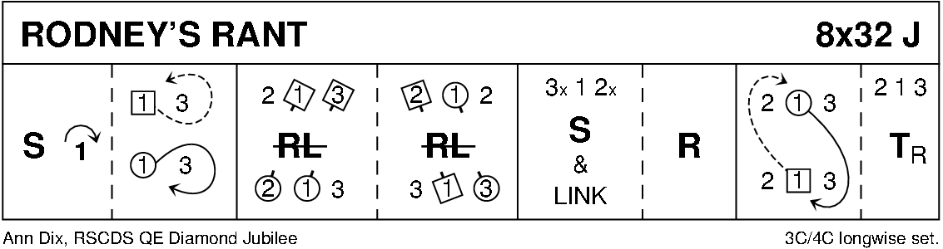
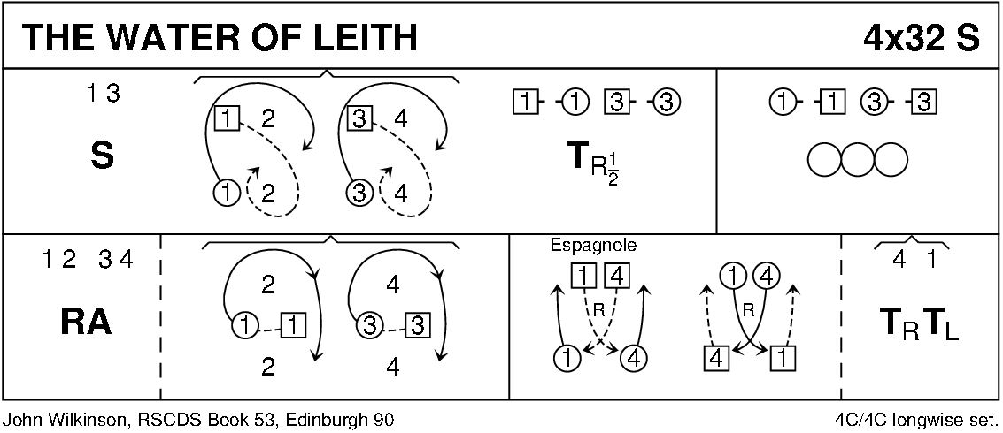

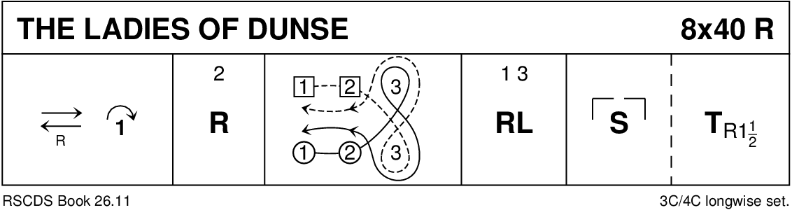
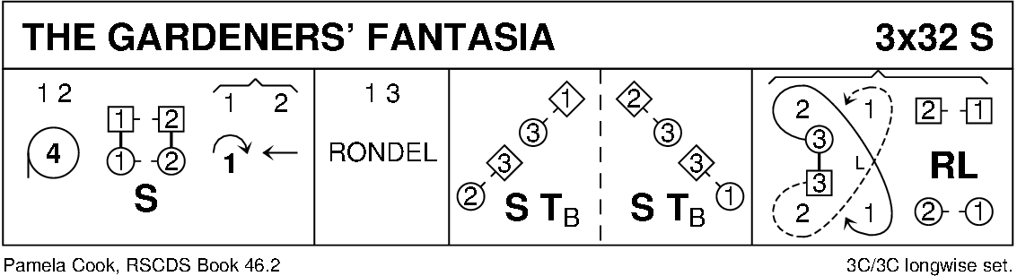
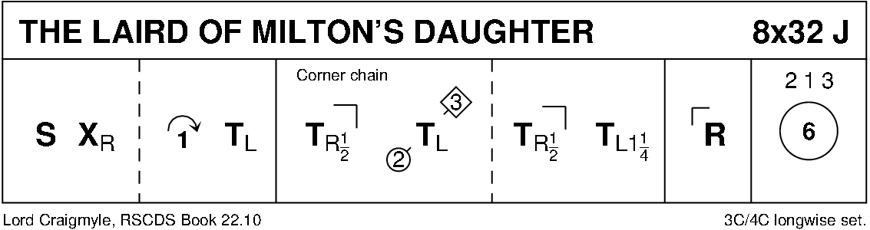
DIAGRAMS CURTESY OF KEITH ROSE, BEDFORD

