TUESDAY 30 JULY 2024 RDMI, SCONE 7.30
EWAN GALLOWAY FIONA GOUDIE
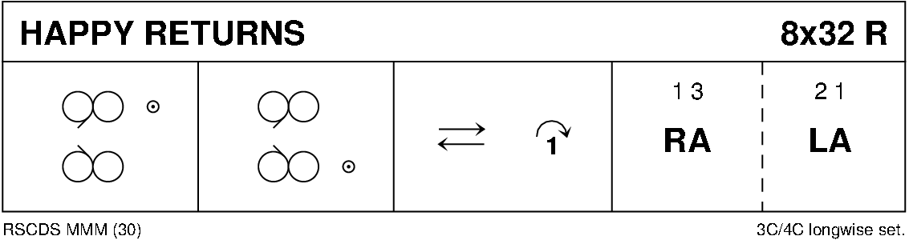
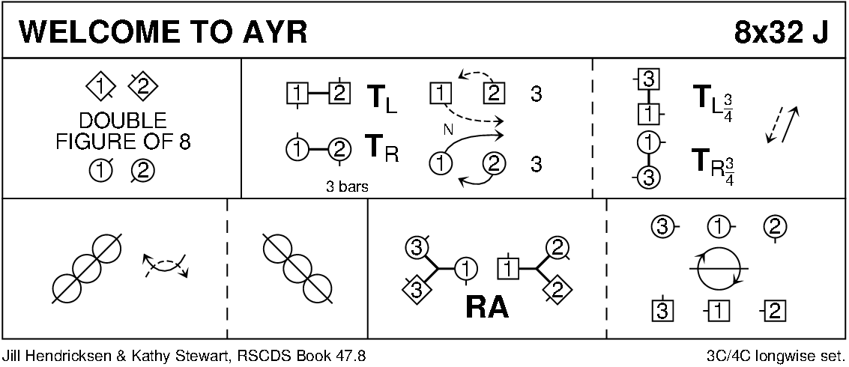
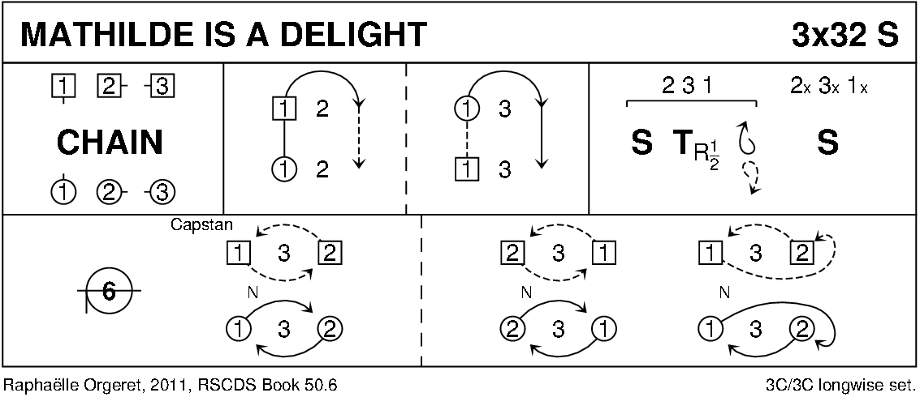
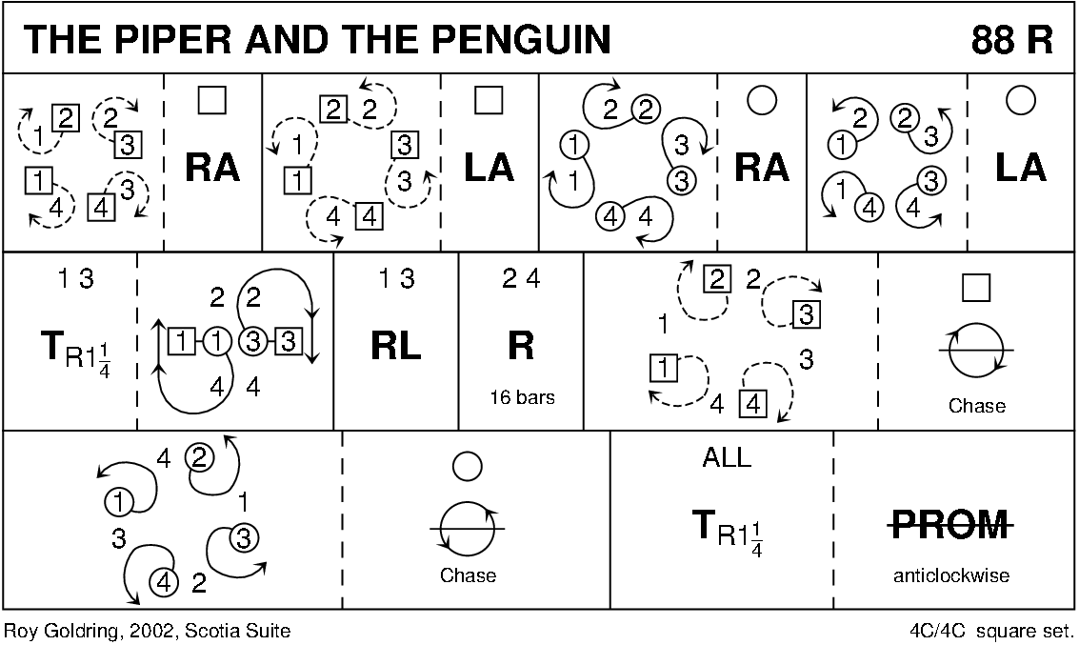
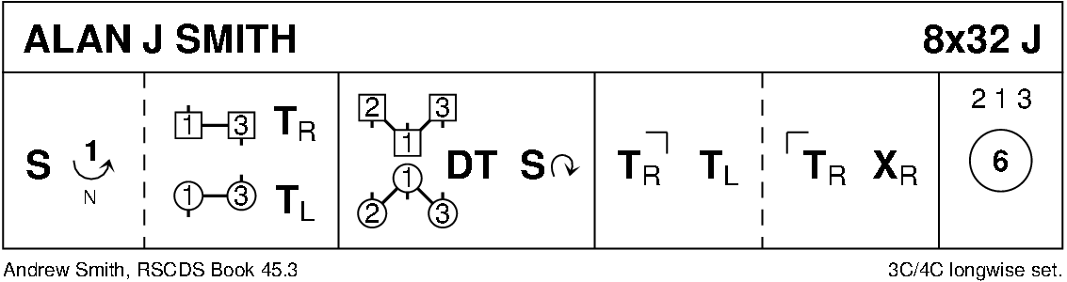
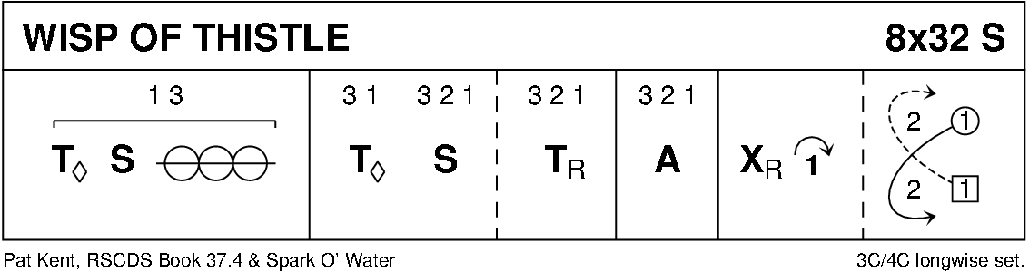
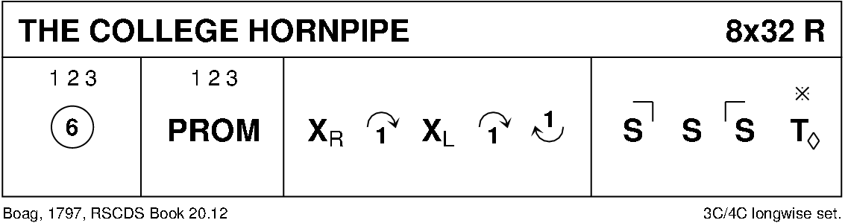
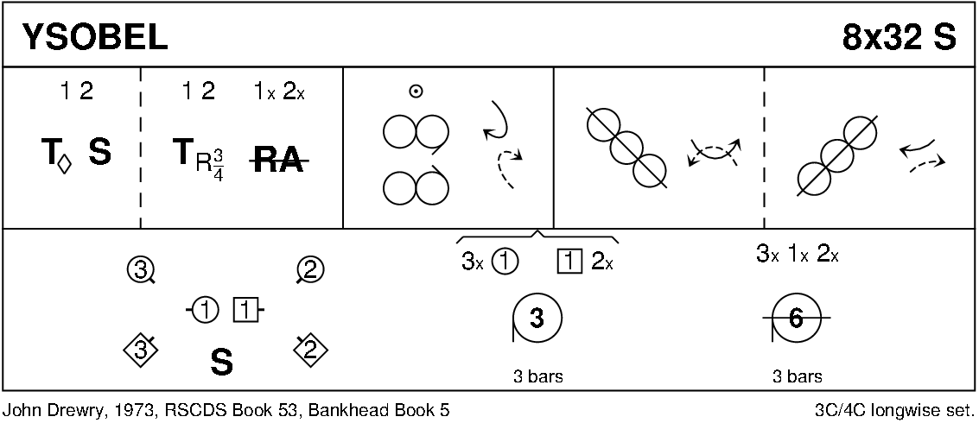
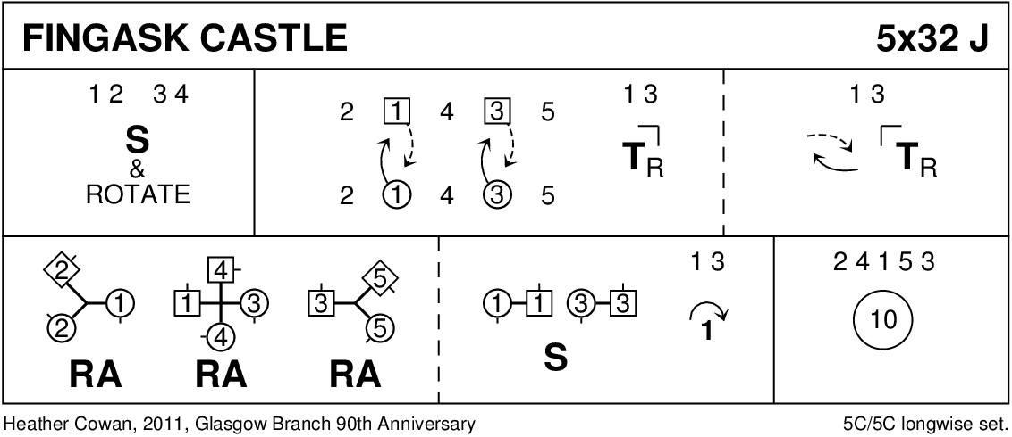
INTERVAL
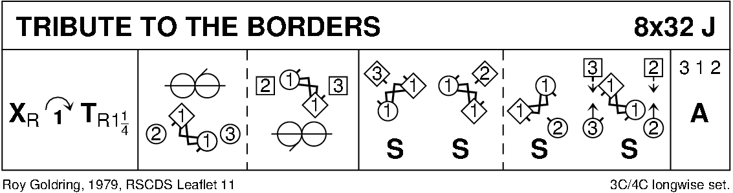
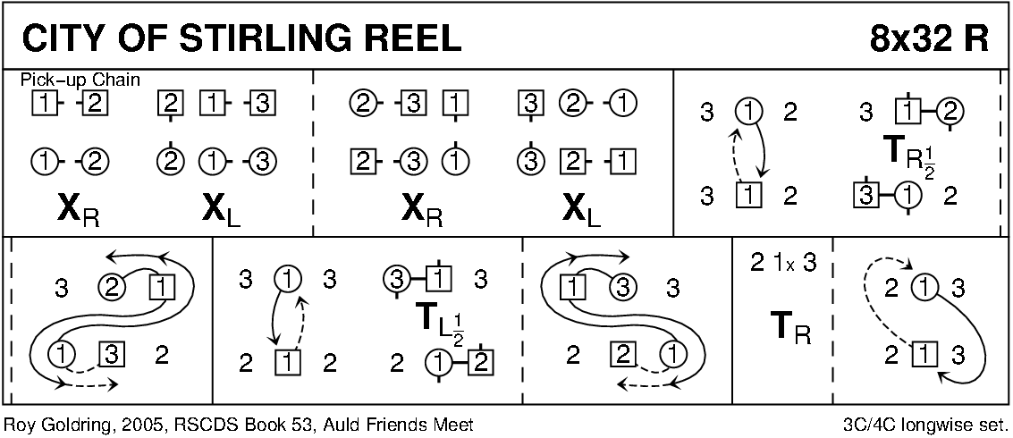
WILD ROSE OF THE MOUNTAINS SQ S4x32

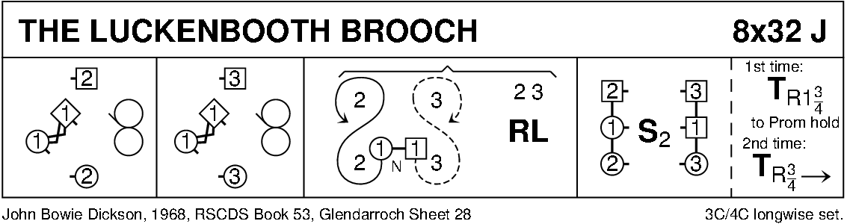
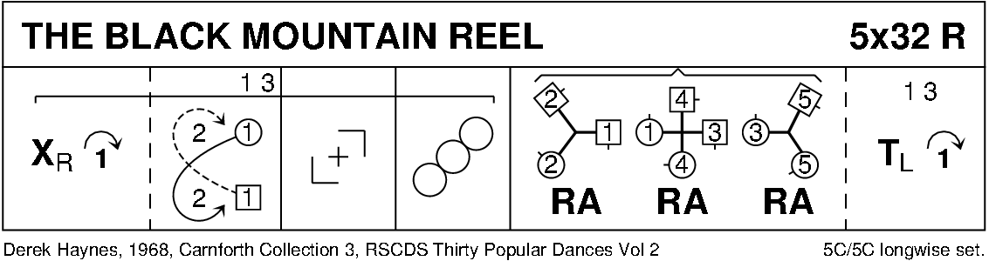

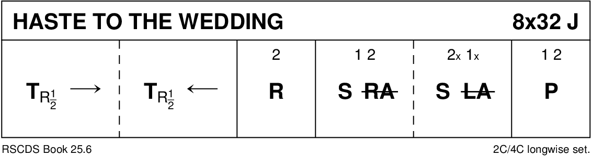
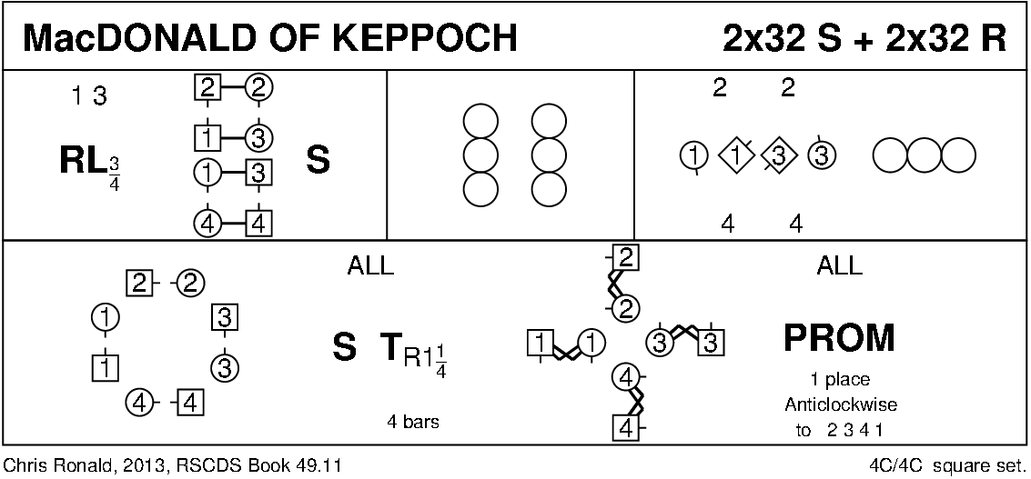
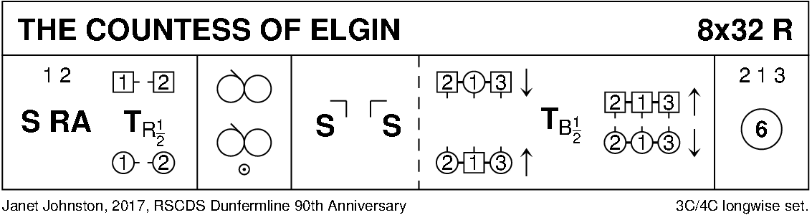
DIGRAMS CURTESY OF KEITH ROSE, BEDFORD

