TUESDAY 2 JULY 2024 RDMI, SCONE 7.30
MARIAN ANDERSON ALLANA CREIGHTON
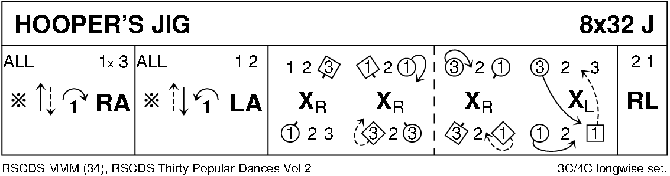
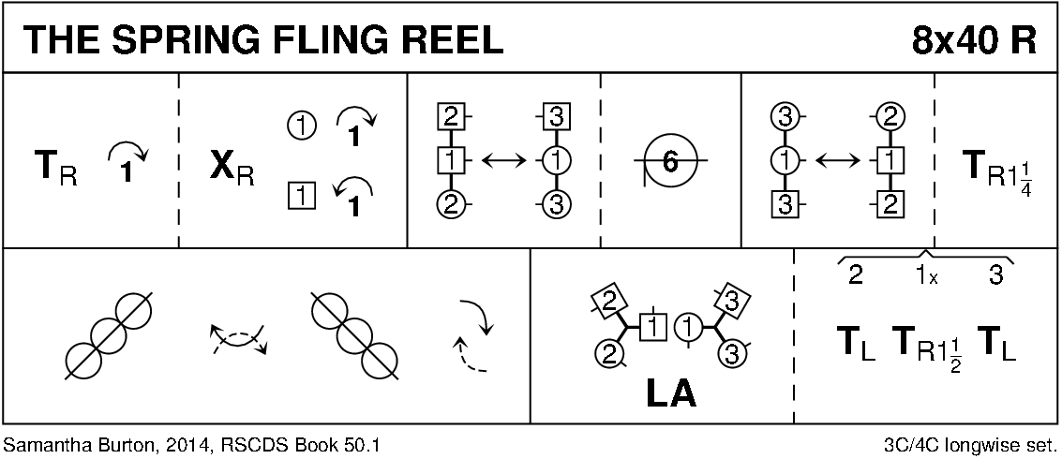
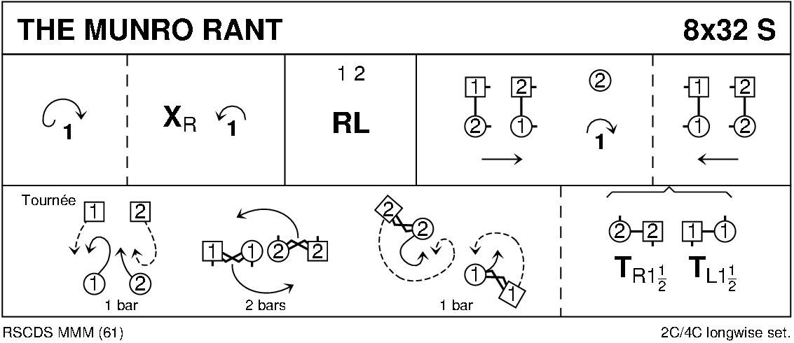
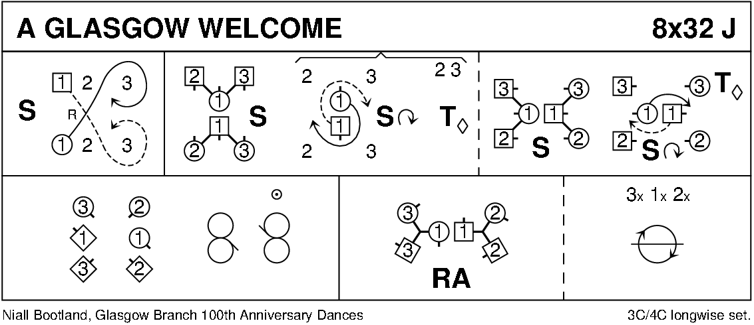
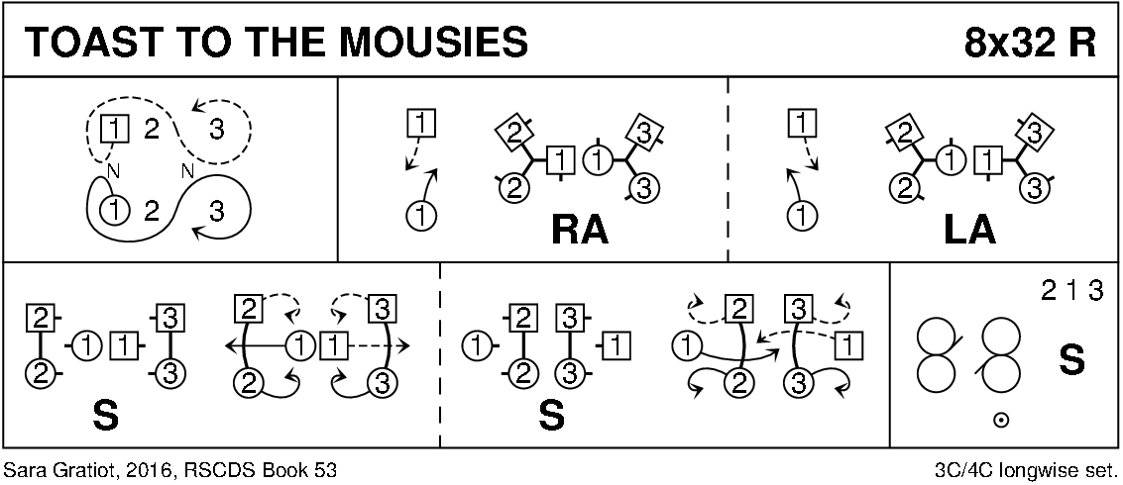
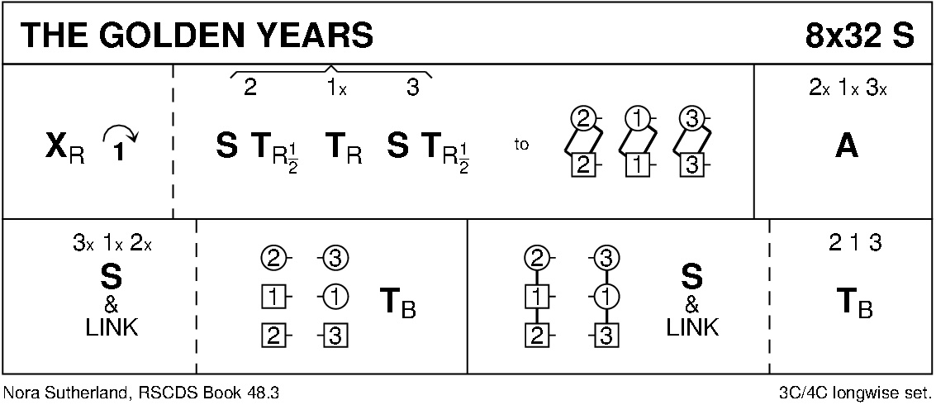
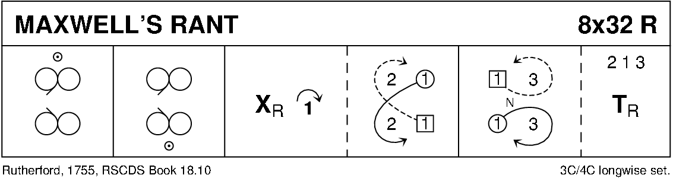
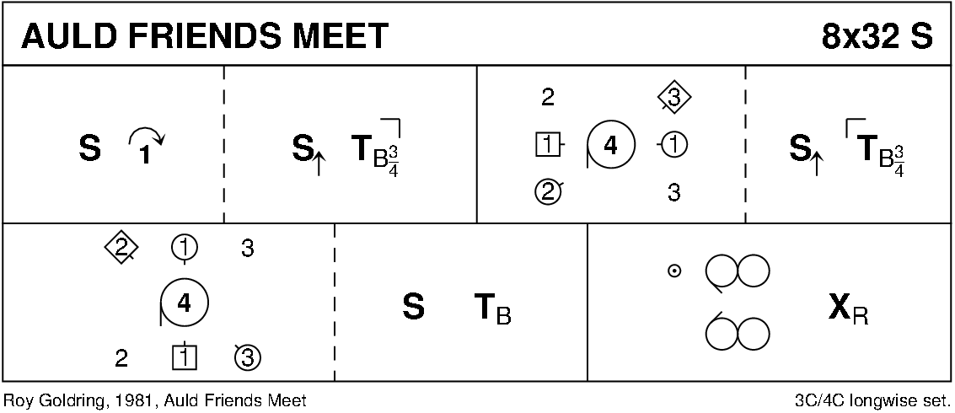
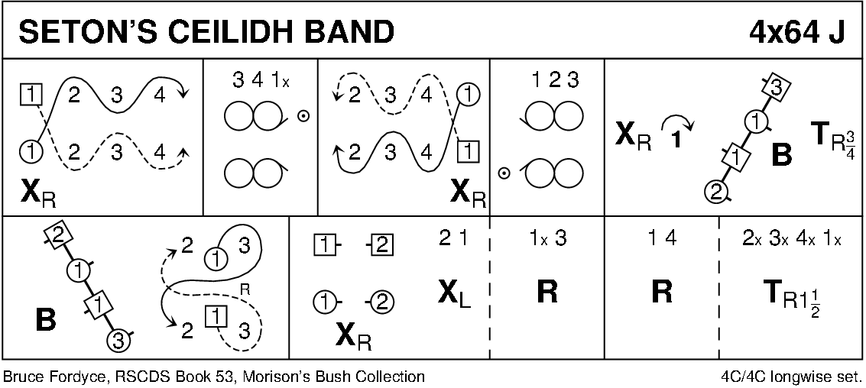
INTERVAL
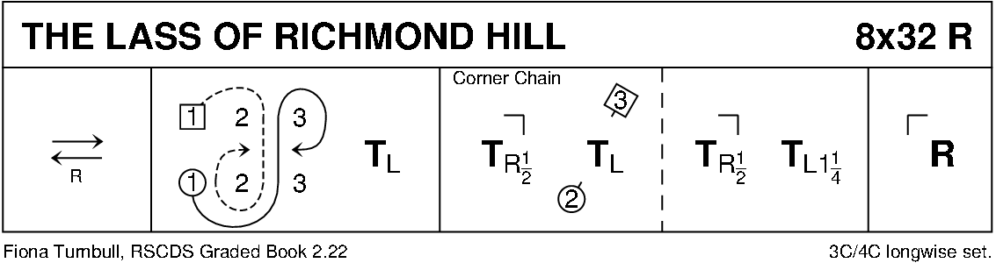
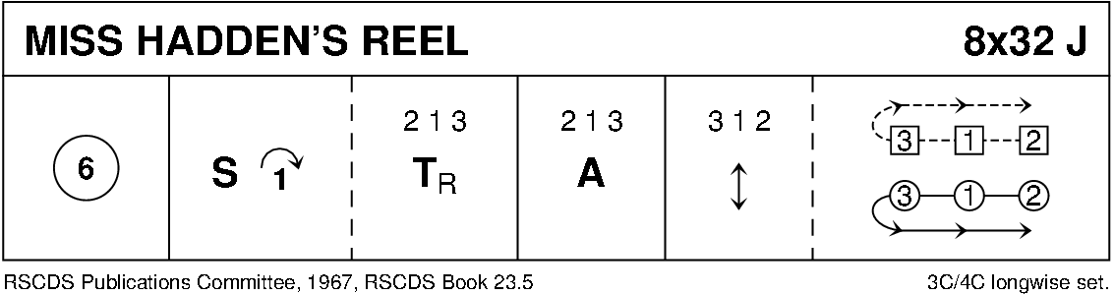
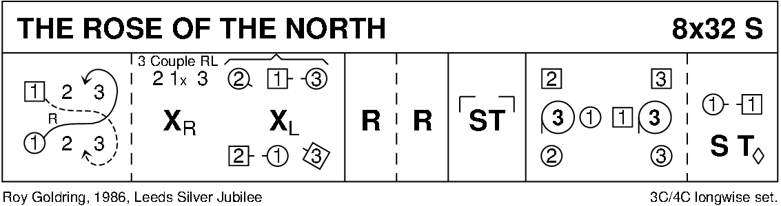
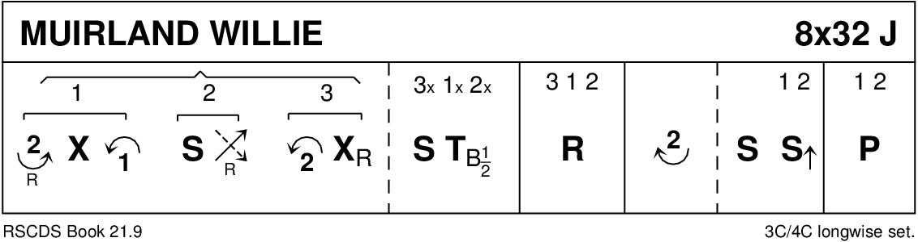
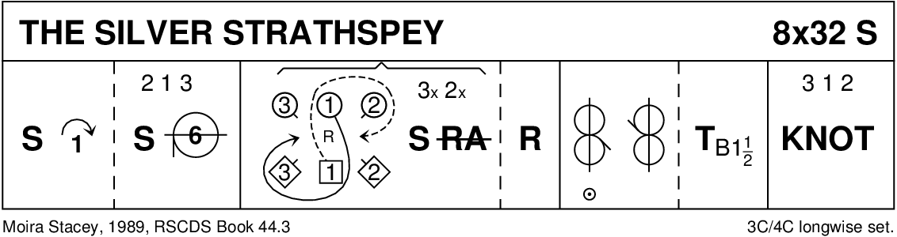
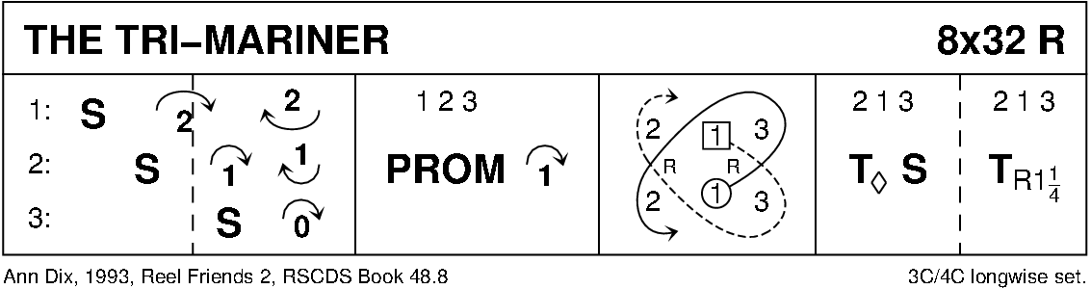

THE EXTRA DAY (J8x40 in 10 bar phrases) 3C (4C set) Malcolm Frost, 2004
1-10 1s lead down middle and back to top then cast to 2nd place
11-20 1s dance RH across (1M with 3s, 1L with 2s) and dance LH across with other couple then 1s turn RH to end BtoB facing 1st corners
21-28 1s set to and turn 1st corner; set to and turn 2nd corner
29-30 1s turn RH to end BtoB (Man facing up, Lady down)
31-40 1s dance 6 bar reels of 3 on sides (RSh to 2nd corner) and 1s cross RH to 2nd place own side and all set
(MINICRIB. Dance crib compiled by Charles Upton, Deeside Caledonian Society, and his successors)

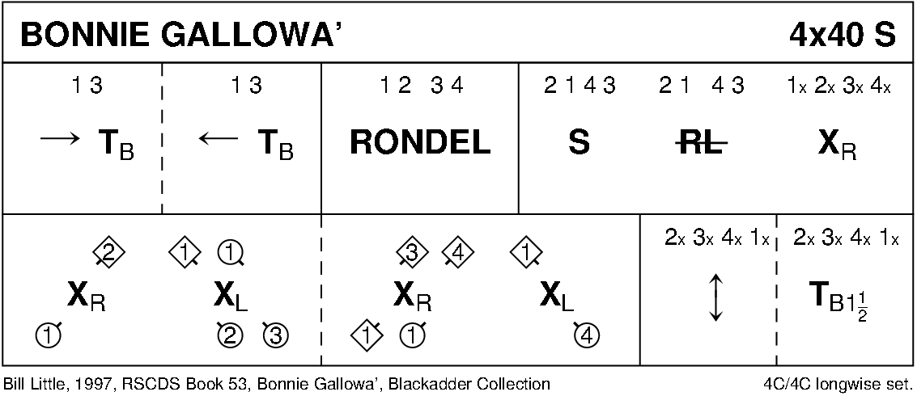
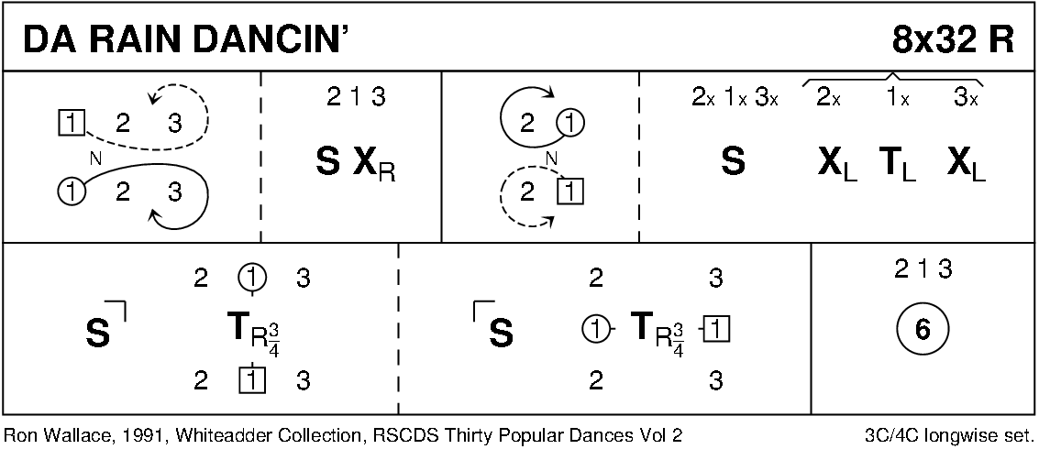
Diagrams curtesy of Keith Rose, Bedford

