Perth & Perthshire RSCDS Tuesday 19 July 2022
Theresa MacVarish Clark Marian Anderson
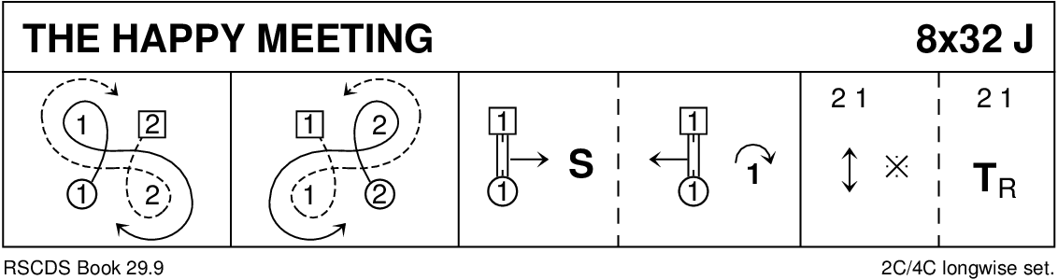
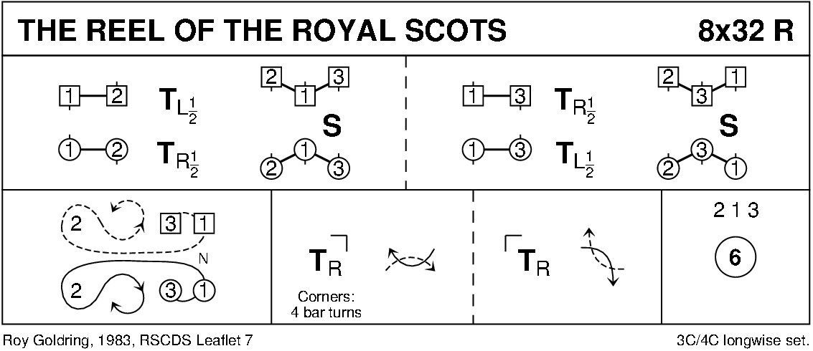
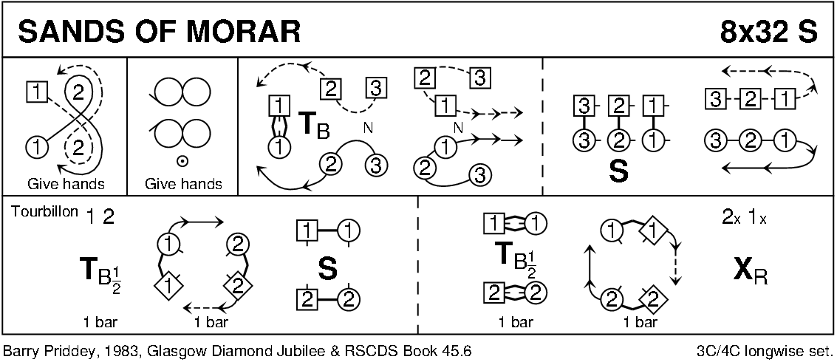
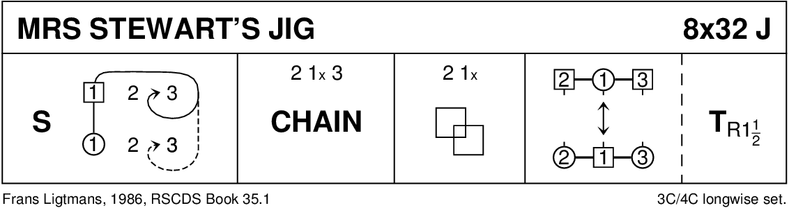
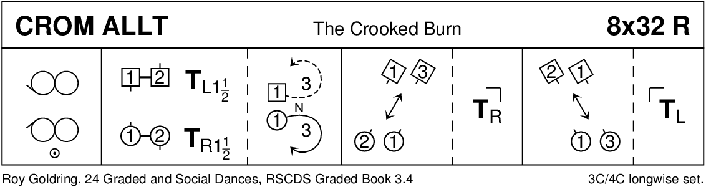
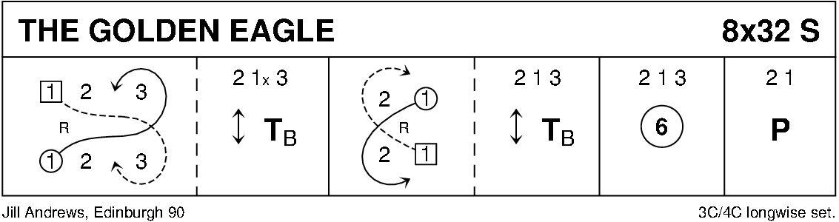
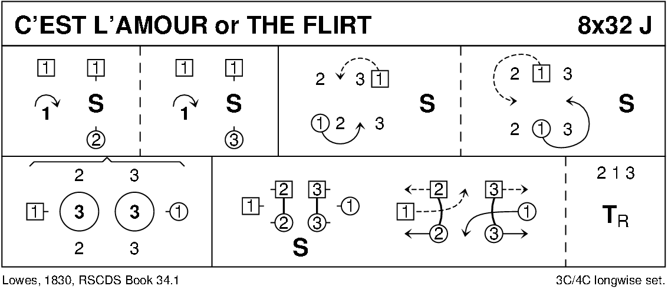
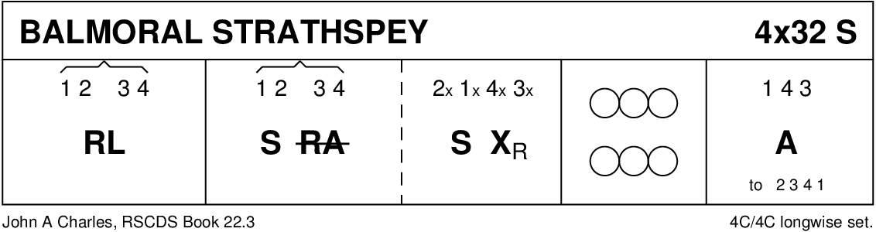
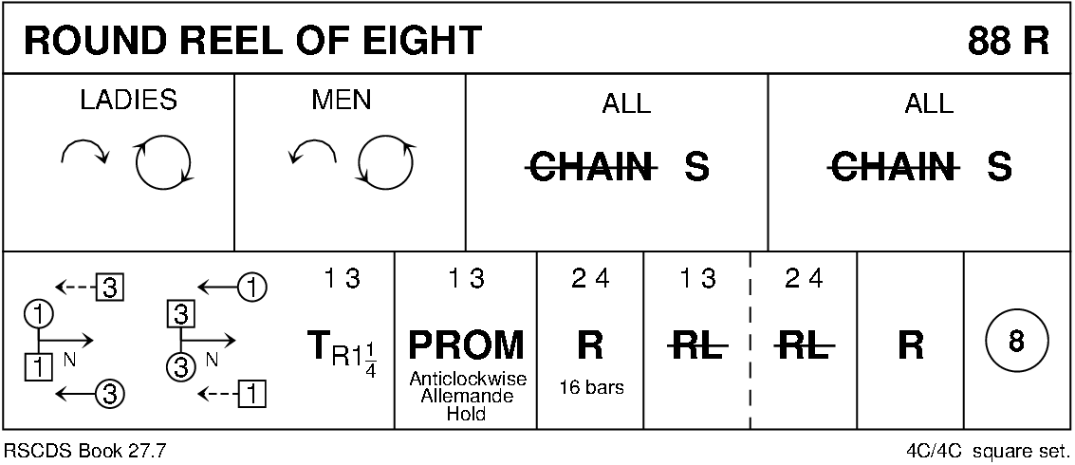INTERVAL
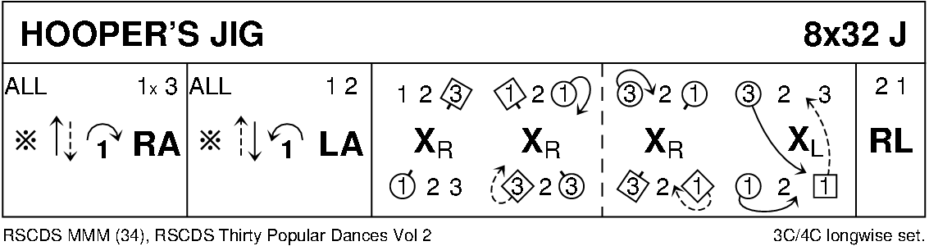
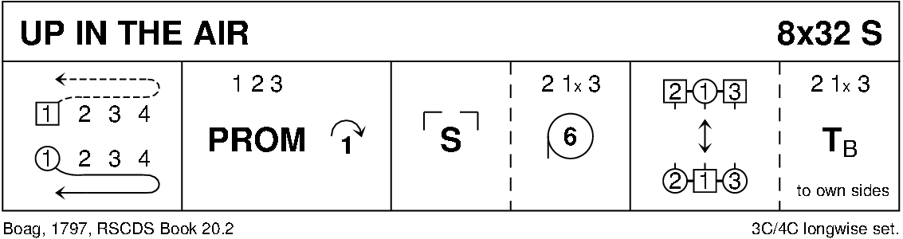
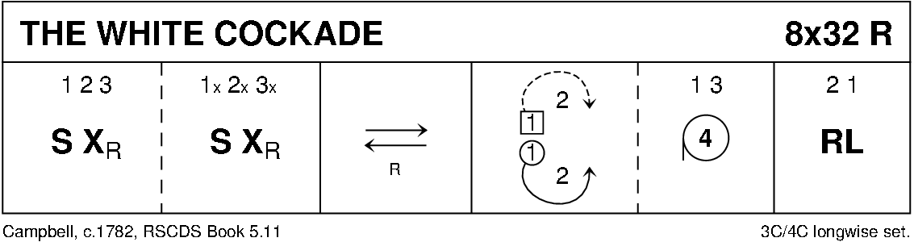
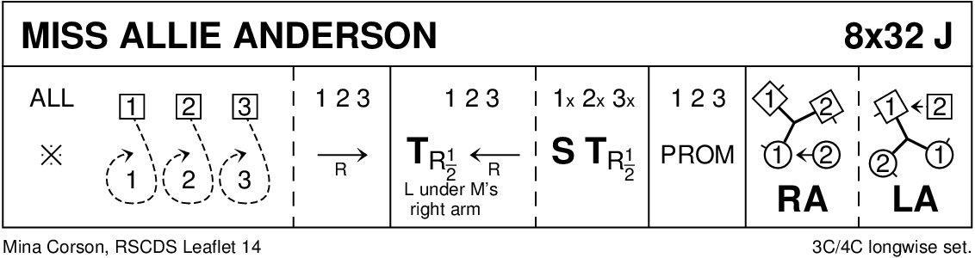
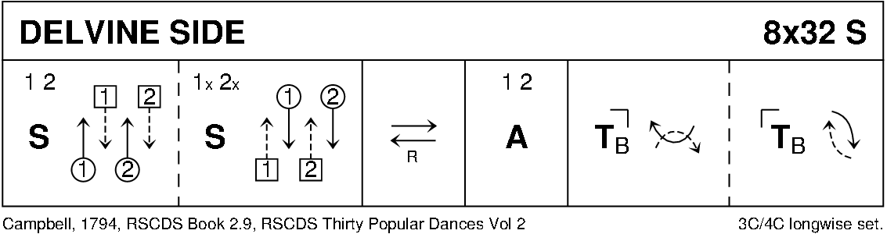
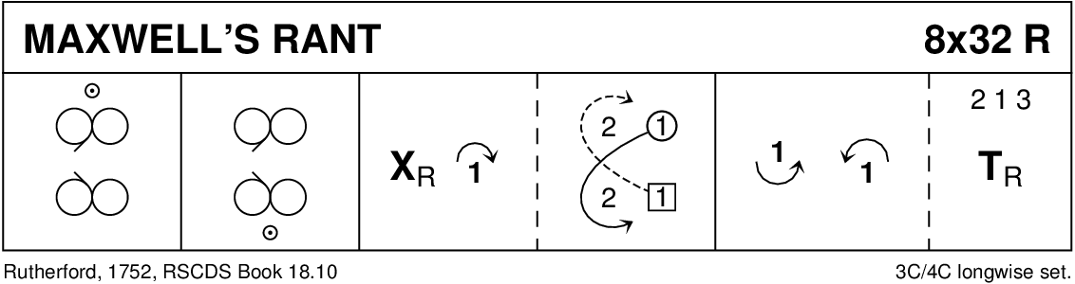
ALIVE AT 95 – A PERTHSHIRE JIG (J8X32) P&P95

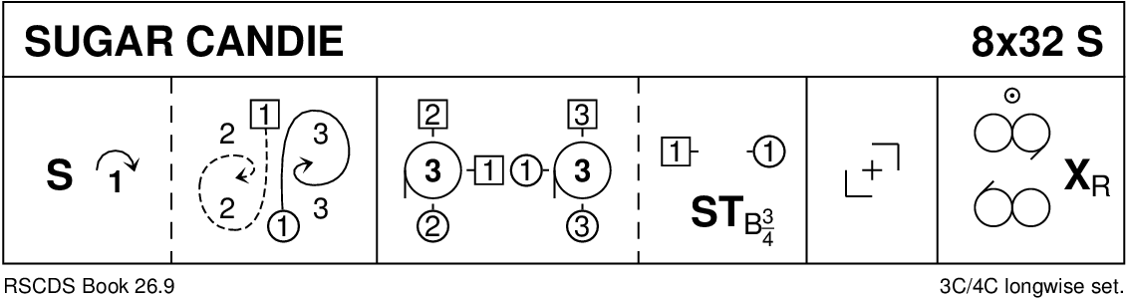
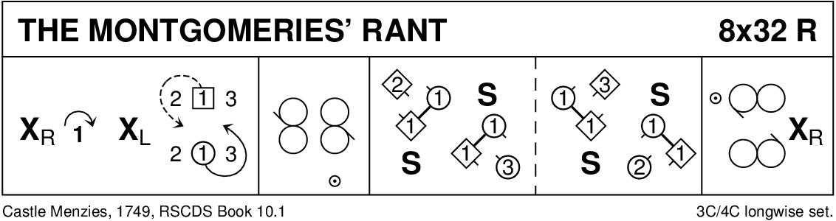
Keith Rose’s Crib Diagrams

