Perth & Perthshire RSCDS Tuesday 2 August 2022
June Templeman Jim Lindsay
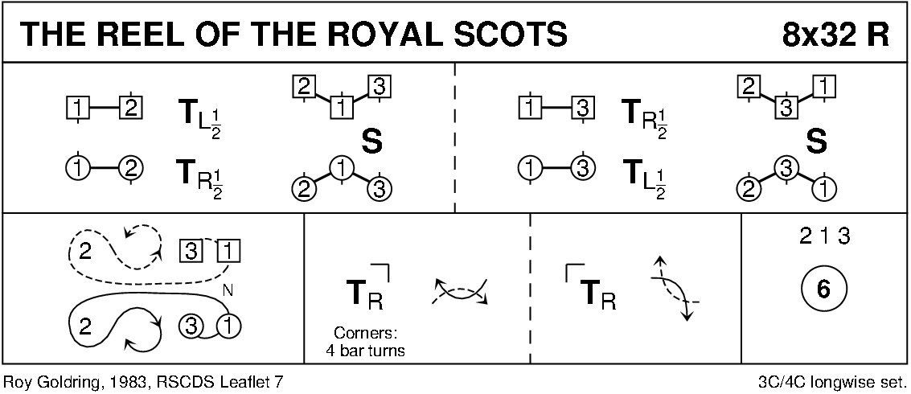
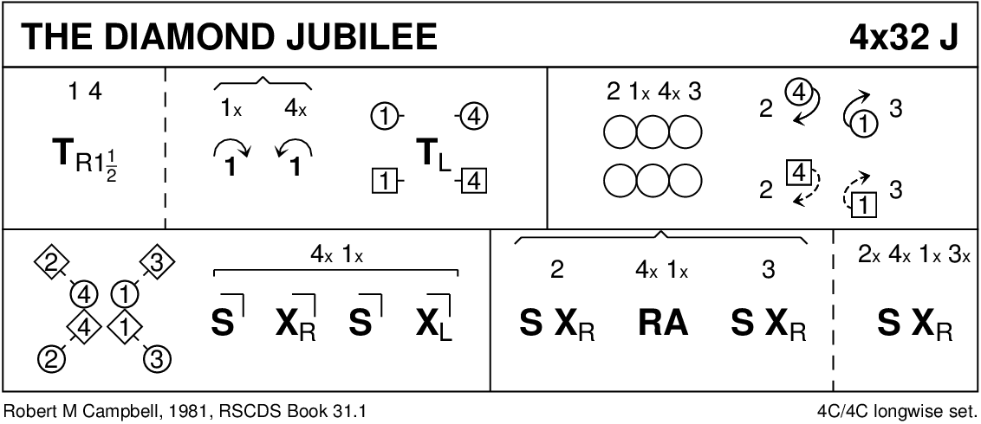
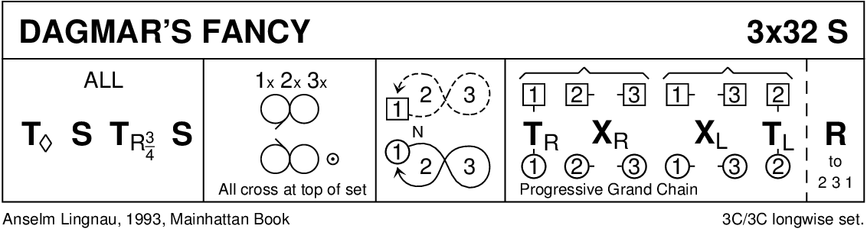
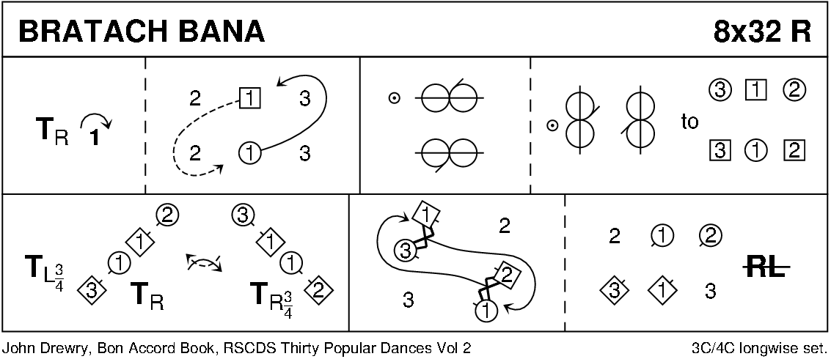
MY GOLDEN BEAR (J4X32) 2# R DOWNEY

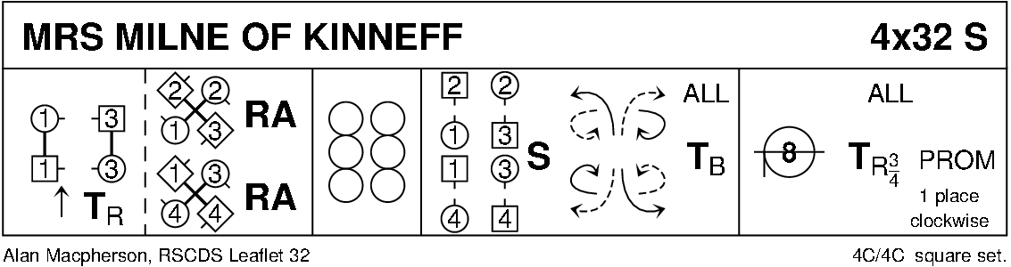
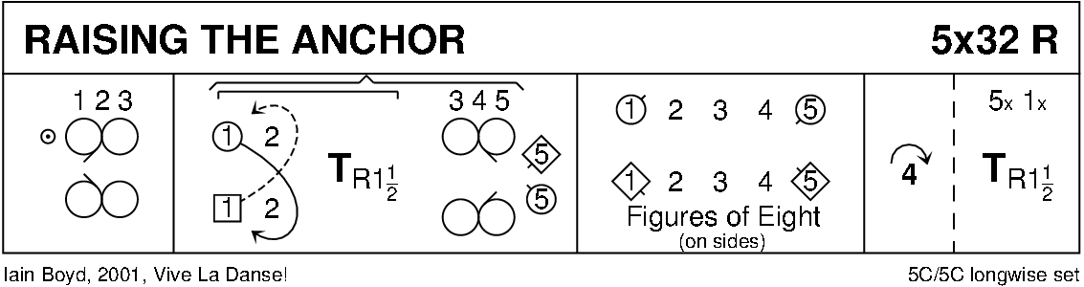
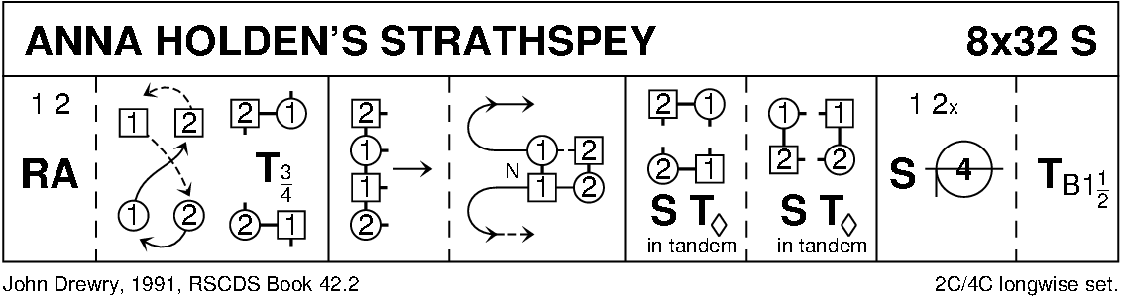
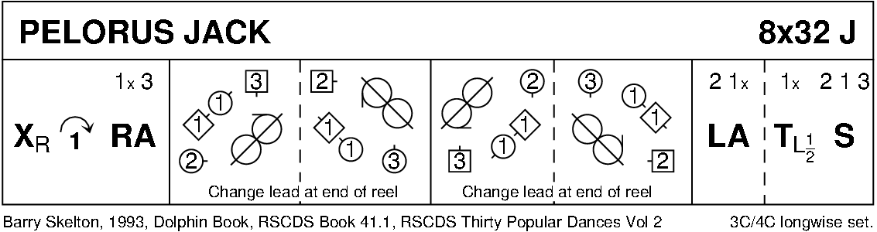
INTERVAL
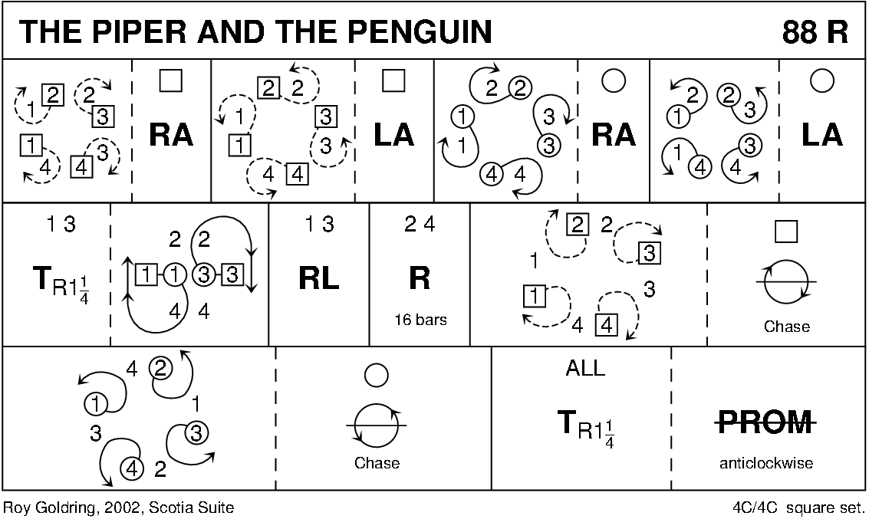
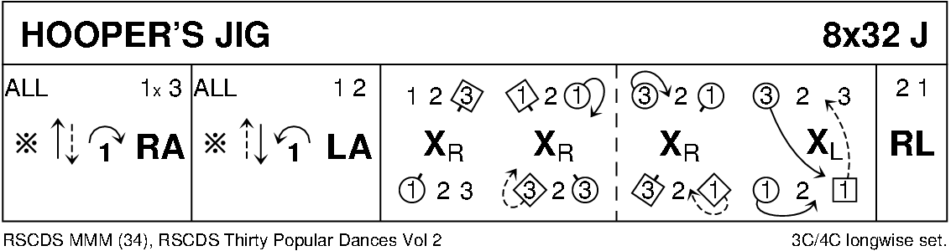
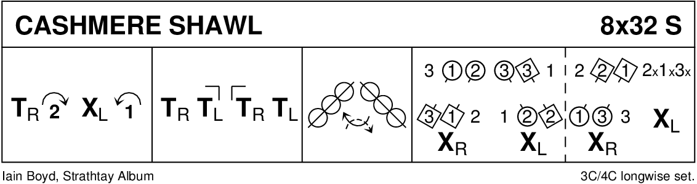
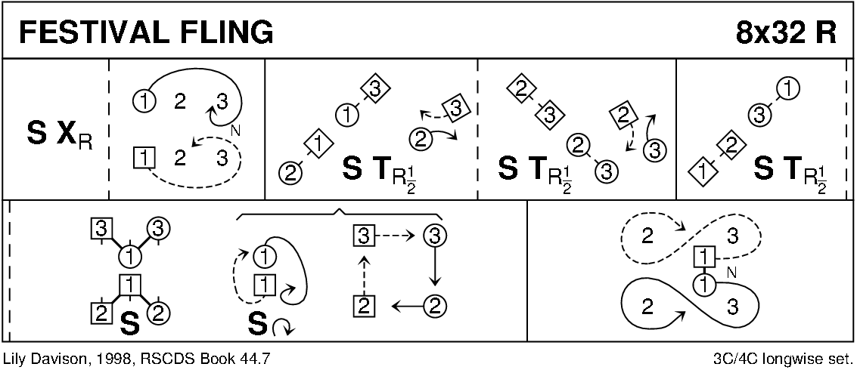
SHEPHERD’S DELIGHT (J4X32) C WALKER

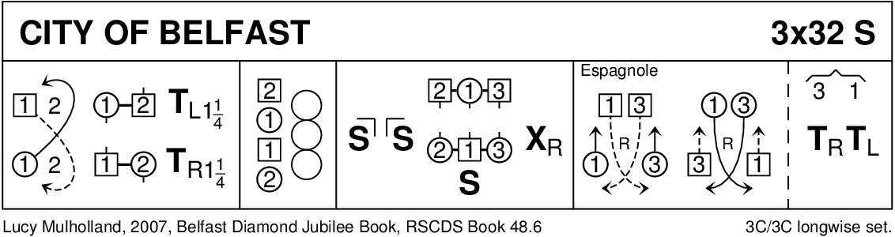
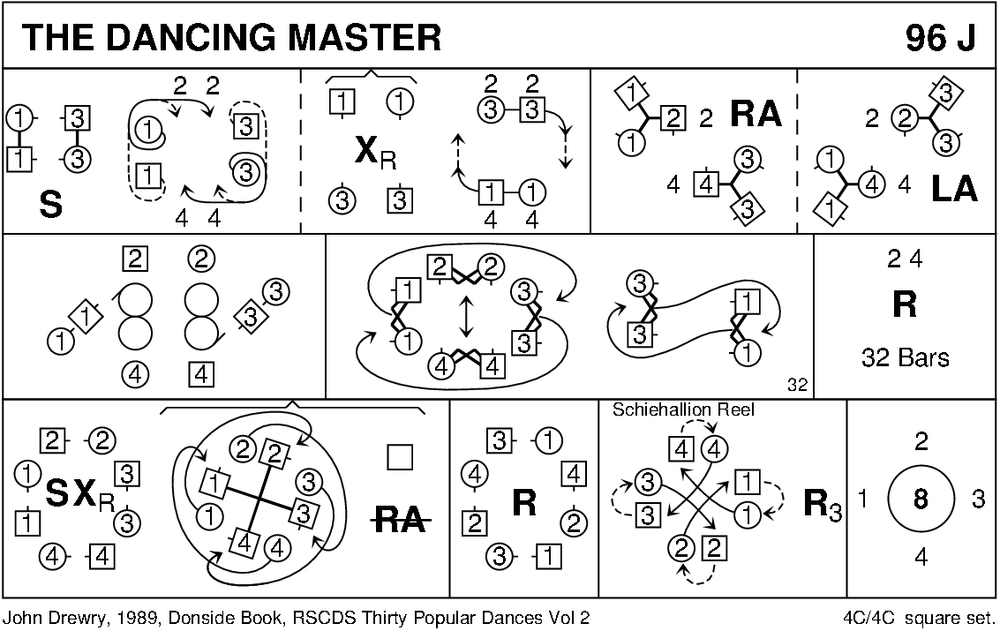
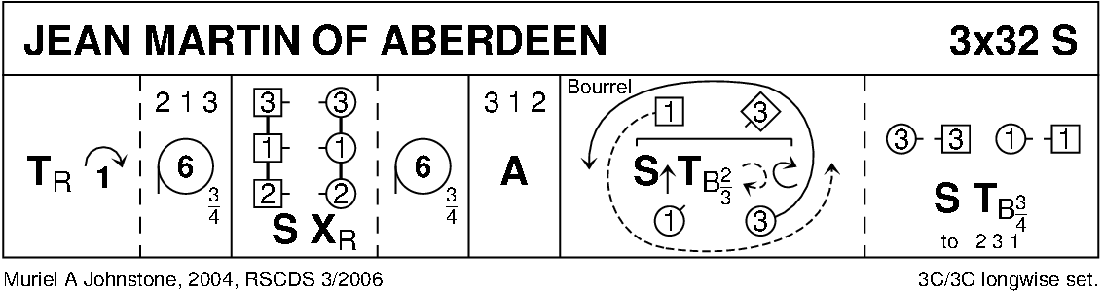
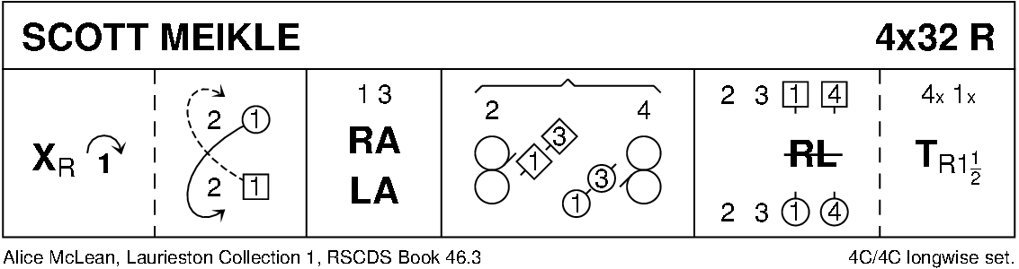
Keith Rose’s Crib Diagrams

